**Project Report**

**On**

**“SSDLC in CI/CD”**



Submitted in fulfilment for the award of   
**Post Graduate Diploma**

**in IT Infrastructure System & Security (PG-DITISS)** from

CDAC ACTS (Pune)

Guided By:

Mr. Roshan Gami

**Presented By:**

Tanmay Gurav PRN-240840123018

Konda Sindhu PRN-240840123025

Navjot Bhatia PRN-240840123035

Purva Giri PRN-240840123041

Snehal Bhamare PRN-240840123052

**CERTIFICATE**

TO WHOMSOEVER IT MAY CONCERN

This is to certify that

Tanmay Gurav PRN-240840123018

Konda Sindhu PRN-240840123025

Navjot Bhatia PRN-240840123035

Purva Giri PRN-240840123041

Snehal Bhamare PRN-240840123052

Have successfully completed their project on

**“SSDLC in CI/CD”**

Under the guidance of

Mr. Roshan Gami

Project Guide Project Supervisor

**ACKNOWLEDGEMENT**

This project “SSDLC in CI/CD” was a great learning experience for us and we are submitting this work to Advanced Computing Training School (CDAC ACTS). We all are very glad to mention the name of Mr. Roshan Gami for his valuable guidance to work on this project. His guidance and support helped us to overcome various obstacles and intricacies during the course of project work.

We are highly grateful to Mrs. Namrata Ailawar (Joint Director (ACTS training Centre), C-DAC, for her guidance and support whenever necessary while doing this course Post Graduate Diploma in IT Infrastructure, System & Security (PG- DITISS) through C-DAC ACTS, Pune.

Our most heartfelt thanks go to Miss. Sajida Shaikh (Course Coordinator, PG DITISS) who gave all the required support and kind Co-ordination to provide all the necessities like required hardware, internet facility and extra Lab- hours to complete the project and throughout the course up to the last day here in C DAC ACTS, Pune.

Sincerely,

Tanmay Gurav

Konda Sindhuja

Navjot Bhatia

Purva Giri

Snehal Bhamare

**ABSTRACT**

The **Jenkins Server CI/CD Security Pipeline** project focuses on automating security scanning and vulnerability management within a CI/CD environment. Jenkins is configured with essential security tools such as **OWASP ZAP**, **TruffleHog3**, **OWASP Dependency Checker**, **SonarQube**, and **DefectDojo**. The pipeline ensures secure code deployment by integrating **static code analysis**, **secret detection**, and **dependency vulnerability checks**.

Key configurations include **Jenkins installation**, **SonarQube setup via Docker**, and **DefectDojo integration for centralized vulnerability management**. Additionally, **SSH key-based authentication** is established for secure communication between Jenkins and application servers. The project also enables **automated API token authentication** for seamless Jenkins-SonarQube interactions. Troubleshooting steps, such as resolving SSH authentication issues and password-less sudo access, are also implemented. This setup ensures a **robust DevSecOps pipeline** with continuous security monitoring and risk mitigation.

**TABLE OF CONTENTS**

1. Introduction

2. Prerequisites

Software Requirements

System Requirements

3. Data Flow Diagram

4. Lab setup steps

5. Working

6. Implementation & Outputs

7. Conclusion

8. References

**INTRODUCTION**

In modern software development, ensuring the security of applications during their lifecycle is paramount. The Secure Software Development Lifecycle (SSDLC) aims to incorporate security practices into every phase of the development process. This project, titled SSDLC in CI/CD, focuses on integrating security into the Continuous Integration and Continuous Deployment (CI/CD) pipeline to automate security testing and vulnerability detection.

The project starts with the installation and configuration of Jenkins, a widely-used automation server that will serve as the core of the CI/CD pipeline. Necessary dependencies, such as Java, Git, and Maven, are set up to enable Jenkins to run smoothly. Additionally, SSH key-based authentication is configured between Jenkins and application servers to ensure secure communication.

To enhance security within the pipeline, several open-source security tools are integrated with Jenkins. OWASP ZAP is employed for Dynamic Application Security Testing (DAST) to detect runtime vulnerabilities, while TruffleHog3 scans repositories for exposed secrets and sensitive data. OWASP Dependency Checker is used to assess the security of third-party libraries, and SonarQube performs Static Application Security Testing (SAST) on the source code to identify security issues early in the development process. Additionally, DefectDojo is implemented to centralize the tracking and management of vulnerabilities identified by these tools.

The security tools are containerized using Docker for easier deployment and management. SonarQube and DefectDojo are deployed within Docker containers, ensuring that they run efficiently and independently from the host system.

To ensure smooth integration, Jenkins communicates securely with SonarQube through an API token that is stored in Jenkins credentials. This setup allows Jenkins to automatically trigger security scans during the build process and integrate the results into the pipeline.

The integration of DefectDojo provides a centralized platform for managing and prioritizing vulnerabilities discovered by SonarQube and other security tools. This enables teams to track security issues, assign remediation tasks, and ensure that vulnerabilities are addressed before deployment.

To ensure the reliability of the system, troubleshooting steps are implemented for resolving common issues such as SSH authentication errors and password-less sudo access for Jenkins automation.

The SSDLC in CI/CD project ultimately creates a comprehensive DevSecOps pipeline, where security is built into every step of the development and deployment process. By automating security testing, vulnerability management, and remediation, this project enables organizations to securely and efficiently deploy applications while maintaining high standards of security throughout the development lifecycle.

**PREREQUISITES**

VMware Workstation Hypervisor:

• Used to create and manage virtual machines (VMs).

• Hosts VMs for installation of tools and services.

• Installed on the host machine for running virtual machines.

VMs with NAT Configuration:

• VMs set up on the VMware Workstation hypervisor.

• Configured with NAT mode for network communication.

• Assigned IPs through the NAT gateway.

Software Requirements:

• Jenkins: A popular CI/CD tool for code building, testing, and deployment.

• OWASP ZAP: A security testing tool for dynamic application security testing.

• TruffleHog3: A tool for detecting sensitive information in Git repositories.

• OWASP Dependency-Check: A tool for identifying vulnerable dependencies.

• SonarQube (via Docker): A tool for static code analysis.

• DefectDojo: An open-source vulnerability management tool.

SSH Key-based Authentication:

• Secure, password-less communication between Jenkins and other application servers.

• Set up and configured for secure communication.

Automated API Token Authentication (for Jenkins-SonarQube Integration):

• Used to automate the authentication process between Jenkins and SonarQube.

• Generated on SonarQube and configured in Jenkins.

Password-less Sudo Access:

• Configured on the VM to allow Jenkins and other tools to interact with SonarQube.

Github Integration

• Github account logged in and cloned repository

**DATAFLOW DIAGRAM**

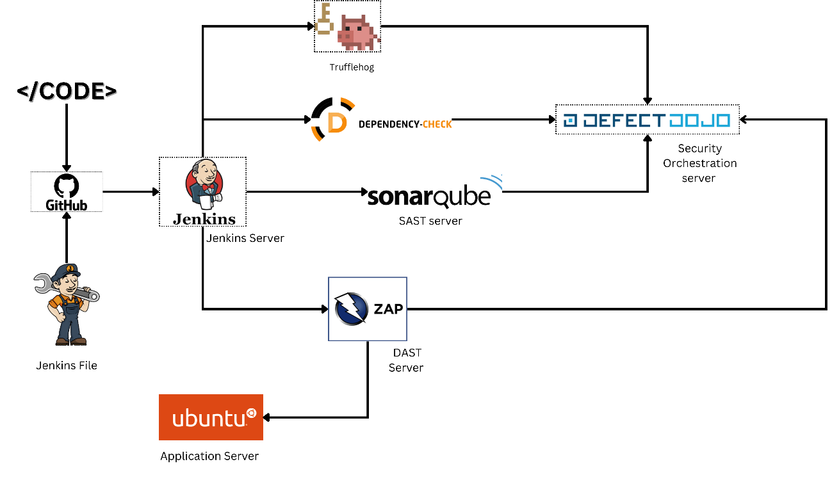  
Fig. 1 Flow of the Project

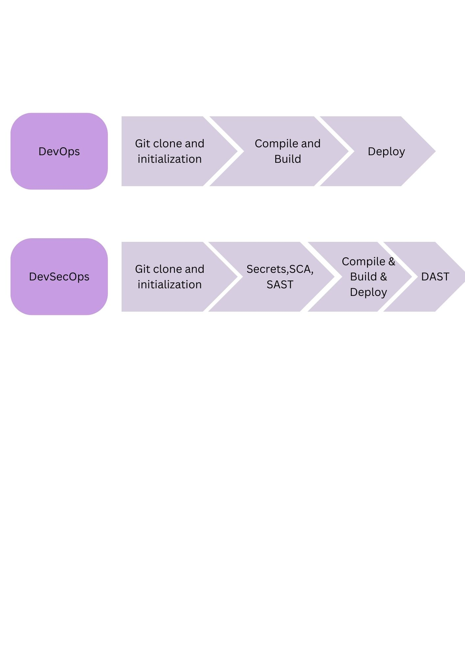  
Fig. 2 Flow of the DevOps and DevSecOps

VM Lab Setup details:

**Lab Setup Overview**

The goal of the setup is to have a Continuous Integration (CI) pipeline where Jenkins orchestrates builds and integrates with tools like SonarQube for static code analysis, OWASP ZAP for security scanning, and DefectDojo for tracking vulnerabilities. The configuration will span across three VMs, each running different components:

1. **VM 1 (Jenkins Server)**: This VM will host Jenkins and its related services, which will drive the build pipeline and interact with other tools (SonarQube, OWASP ZAP).
2. **VM 2 (SonarQube Server)**: This VM will run SonarQube for static code analysis.
3. **VM 3 (Application Server)**: This VM will host your application code and will be used for running security scans (OWASP ZAP) and for integrating with tools like DefectDojo for vulnerability management.

**VM 1: Jenkins Server Configuration**

Jenkins is the heart of the CI pipeline. It manages the build process, triggering various tools (SonarQube, OWASP ZAP) to analyze and scan the application.

**Key Steps for Jenkins Setup:**

**Install Jenkins**: First, you need to install Jenkins on VM 1. You will install Java (as Jenkins requires it) and then Jenkins itself. After installation, Jenkins is typically accessible via a web interface on port 8080 (http://:8080).

* **Install Plugins**: After setting up Jenkins, install the necessary plugins. For example:
  + **SonarQube Plugin**: This plugin integrates Jenkins with SonarQube, allowing Jenkins to trigger SonarQube scans after the build is completed.
  + **OWASP Dependency-Check Plugin**: This plugin can be used for analyzing project dependencies for vulnerabilities.
  + **Git Plugin**: This will allow Jenkins to pull code from a Git repository and trigger builds.

**Secrets and Credentials Management:**

* **API Token for SonarQube**: In Jenkins, you will need to configure the SonarQube server communication. This requires creating an API token in the SonarQube server (running on VM 2) and adding it to Jenkins under "Manage Jenkins > Credentials".
* **SSH Key Exchange**: To enable Jenkins to securely communicate with the application server (VM 3), you will exchange SSH keys between Jenkins and the application server. This will allow Jenkins to perform tasks like copying build artifacts to the application server without needing a password prompt.

**VM 2: SonarQube Server Configuration**

SonarQube provides static code analysis to identify bugs, vulnerabilities, and code smells. It should be installed on a separate VM (VM 2), so Jenkins can connect to it and trigger scans remotely.

**Key Steps for SonarQube Setup:**

* **Docker Installation**: SonarQube will run in a Docker container on VM 2. Ensure Docker is installed on this VM. You'll pull the SonarQube Docker image and start the container on a specific port (default is 9000).
* **API Token**: Once SonarQube is running, generate an API token from the SonarQube dashboard. This token will be used in Jenkins to authenticate SonarQube API calls.
* **Firewall and Network Access**: Ensure that VM 1 (Jenkins Server) can access SonarQube on port 9000. You'll configure this during the SonarQube setup.

**VM 3: Application Server Configuration**

The application server (VM 3) is where your application code will reside. This VM will interact with Jenkins for code analysis and scanning, and with DefectDojo for tracking vulnerabilities.

**Key Steps for Application Server Setup:**

* **SSH Setup**: As mentioned earlier, you need to exchange SSH keys between the Jenkins VM (VM 1) and the application VM (VM 3). This ensures Jenkins can access the application server to deploy artifacts or run scans.
* **OWASP ZAP**: You’ll set up OWASP ZAP, a security scanner, on this VM. ZAP will scan the application for vulnerabilities. It will run in a Docker container, and you’ll configure it to run scans against your application after each build.
* **DefectDojo**: DefectDojo is a vulnerability management tool that helps track security findings from different scanners. You’ll configure DefectDojo on this server to manage the results from SonarQube and OWASP ZAP scans. It will integrate with Jenkins and SonarQube via API calls to pull security-related information.

**Setting Up DefectDojo:**

* **Clone the Repository**: You’ll clone the DefectDojo repository and set up the necessary environment (using Docker Compose to simplify the setup).
* **Product Setup**: In DefectDojo, you will create a new product (e.g., webgoat-devsecops) and link it to the CI/CD pipeline (which is defined in Jenkins). This integration allows DefectDojo to capture vulnerabilities identified during scans.

**Cross-VM Communication:**

Since the setup involves multiple VMs, you'll need to ensure smooth communication between them:

* **Network Configuration**: All VMs need to be on the same network or should be able to communicate over the necessary ports. For instance, Jenkins on VM 1 needs to be able to connect to SonarQube on VM 2 on port 9000.
* **Security Considerations**: Use SSH keys for secure communication and ensure proper permissions are set up for access between Jenkins, SonarQube, and the application server.

**General Flow of the CI/CD Pipeline:**

1. **Code Commit**: Developers push code to the Git repository.
2. **Jenkins Triggers Build**: Jenkins detects changes in the repository and starts a new build. Jenkins pulls the latest code and compiles it (using Maven, for example).
3. **SonarQube Analysis**: After building the code, Jenkins triggers SonarQube to perform static code analysis. The results are stored in SonarQube and can be viewed on its dashboard.
4. **Security Scans (OWASP ZAP)**: Jenkins then triggers an OWASP ZAP scan on the application to check for security vulnerabilities.
5. **Vulnerability Reporting**: Once the scans are completed, the results are pushed to DefectDojo, which tracks vulnerabilities across the different tools used.
6. **Feedback**: The results from SonarQube and OWASP ZAP are visible in Jenkins and DefectDojo, enabling developers to review and act upon security findings.

**Summary of Components and Their Role:**

* **Jenkins Server (VM 1)**: Orchestrates the build process, integrates with SonarQube for static analysis, OWASP ZAP for security testing, and DefectDojo for vulnerability tracking.
* **SonarQube Server (VM 2)**: Provides static code analysis (i.e., bug detection, code smells, vulnerabilities).
* **Application Server (VM 3)**: Hosts the application, interacts with Jenkins for deployments and security scans, and connects to DefectDojo to track vulnerabilities.

The setup provides a robust and scalable CI/CD pipeline with integrated security scanning and vulnerability management across multiple VMs. Each VM plays a distinct role, and their coordination ensures that security is built into the development process.

**WORKING**

**Project Flow Overview**

The primary goal of the setup is to automate the process of building, testing, and deploying code with integrated security and code quality checks. The project is divided into three primary stages:

1. **Build and Static Code Analysis (Jenkins + SonarQube)**
2. **Security Testing (OWASP ZAP)**
3. **Vulnerability Management and Reporting (DefectDojo)**

Each of these steps is orchestrated by **Jenkins**, which acts as the central point of automation. Let's explore each of these stages and how they fit together.

1. **Jenkins Server (VM 1): CI/CD Orchestration**

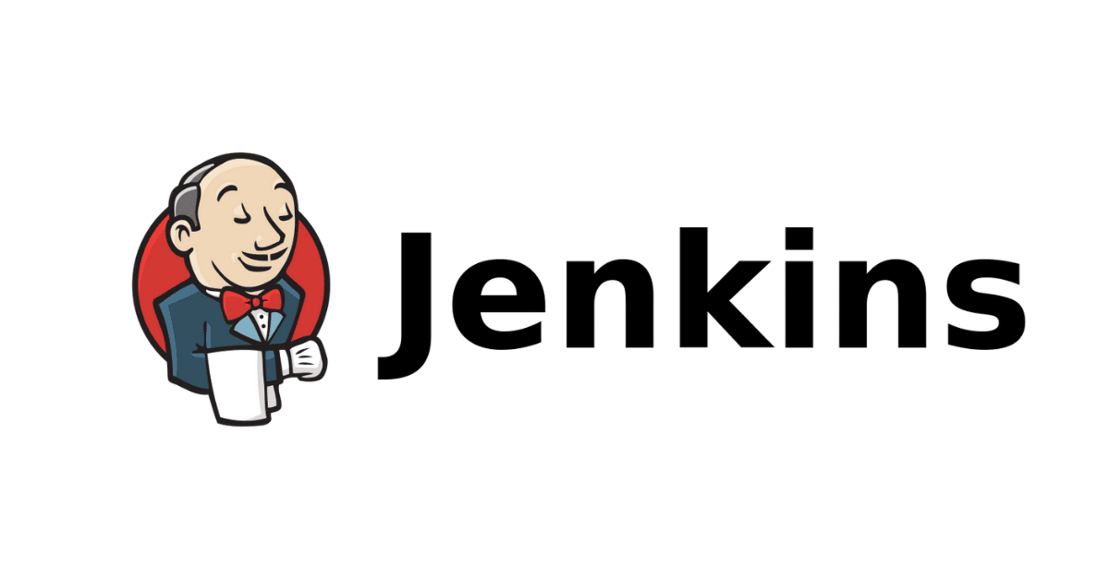

**Jenkins** is the orchestrator of this pipeline, automating the various tasks involved in the build and deployment process. It also integrates with other tools such as SonarQube, OWASP ZAP, and DefectDojo.

**Step-by-Step Flow on Jenkins:**

1. **Code Commit & Build Trigger**:
   * Developers push their code changes to a Git repository (hosted on an external source like GitHub or GitLab).
   * Jenkins listens for any changes in the Git repository using the **Git Plugin**. When a new commit is detected, Jenkins automatically triggers a new build process.
2. **Build Execution**:
   * Jenkins pulls the latest code from the repository and initiates the build process. It can use **Apache Maven** or other build tools depending on the project.
   * The build process involves compiling the code, running tests (unit, integration), and generating build artifacts (e.g., .war or .jar files).
3. **SonarQube Integration**:
   * Once the build is completed, Jenkins automatically triggers a **SonarQube** scan to perform static code analysis.
   * SonarQube checks for various code quality issues such as code smells, bugs, and vulnerabilities in the codebase.
   * Jenkins uses the **SonarQube Plugin** to connect to the SonarQube server (running on VM 2) and submit the analysis results.
   * **API Token Authentication**: Jenkins uses an API token generated from the SonarQube dashboard to authenticate the connection and communicate with SonarQube.
4. **OWASP ZAP Integration**:
   * After the static code analysis, Jenkins triggers an **OWASP ZAP** security scan. This step involves running security tests to check for vulnerabilities in the application.
   * OWASP ZAP is set up on **VM 3** and is accessed via Docker containers. Jenkins sends a request to the OWASP ZAP instance on the application server (VM 3) to initiate the scan.
   * ZAP performs various penetration testing methods, such as scanning for cross-site scripting (XSS), SQL injection, insecure API endpoints, etc.
5. **SonarQube Server (VM 2): Static Code Analysis**



**SonarQube** runs on a dedicated VM (VM 2), separate from Jenkins, to offload the resource-intensive task of static code analysis. It continuously checks the quality of code and identifies issues that might affect maintainability or security.

**Key Flow in SonarQube:**

1. **SonarQube Setup**:
   * SonarQube is set up to run as a Docker container on VM 2. It listens for incoming analysis requests on port 9000.
   * Developers or Jenkins administrators configure the SonarQube server to perform analyses based on predefined rules for Java, JavaScript, Python, or other programming languages.
2. **Analysis Results**:
   * Jenkins sends the results of its builds to SonarQube, which then runs static analysis on the source code to identify issues like:
     + Code smells (i.e., suboptimal code that could be refactored).
     + Bugs (i.e., errors in logic or execution).
     + Security vulnerabilities (e.g., SQL injection, XSS).
   * These results are made available on the SonarQube dashboard, where developers can review them in detail, understand the issues, and address them accordingly.
3. **API Communication**:
   * To allow Jenkins to communicate with SonarQube, an **API Token** is created on SonarQube, which Jenkins uses to authenticate its requests. Jenkins sends the analysis request to SonarQube using this token, ensuring secure communication between the two.
4. **OWASP ZAP (VM 3): Security Testing**



**OWASP ZAP** (Zed Attack Proxy) is used to perform dynamic security testing (also known as penetration testing) on the running application. This tool scans for common security vulnerabilities like SQL injection, cross-site scripting (XSS), and other web-based security issues.

**Key Flow in OWASP ZAP:**

1. **ZAP Setup**:
   * OWASP ZAP is installed as a Docker container on **VM 3**.
   * ZAP is configured to run after each build is completed, ensuring that each new version of the application is checked for security flaws.
2. **Automated Security Scans**:
   * Jenkins triggers OWASP ZAP scans automatically once the build and static analysis are complete.
   * ZAP connects to the running application (hosted on VM 3) and performs automated vulnerability scanning on the application’s web interfaces, APIs, and other exposed endpoints.
3. **Scan Results**:
   * ZAP generates a report detailing the security vulnerabilities discovered during the scan. This report is saved and can be pushed to **DefectDojo** for centralized vulnerability management and tracking.
4. **DefectDojo (VM 3): Vulnerability Management**

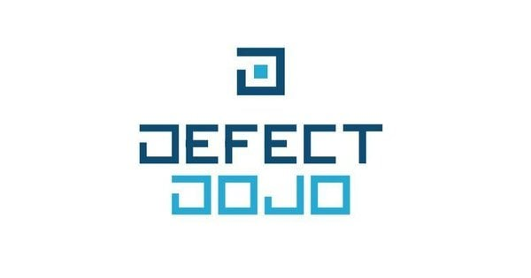

**DefectDojo** is a vulnerability management tool that collects, organizes, and tracks security vulnerabilities discovered by various tools like SonarQube and OWASP ZAP. This helps in maintaining an organized view of vulnerabilities, remediation efforts, and continuous improvement.

**Key Flow in DefectDojo:**

1. **DefectDojo Setup**:
   * DefectDojo is installed and set up on **VM 3** (the application server). It runs in a Docker container.
   * The tool collects vulnerability data from multiple scanners, including SonarQube and OWASP ZAP, and organizes this data into products and engagements.
2. **Integrating with Jenkins**:
   * Jenkins is configured to push the results of both SonarQube (static code analysis) and OWASP ZAP (dynamic security scans) into DefectDojo.
   * This integration helps security teams track and manage vulnerabilities, prioritize them based on severity, and work with development teams to fix them.
3. **Tracking Vulnerabilities**:
   * Each security finding is recorded as a vulnerability entry in DefectDojo, allowing security professionals to monitor progress, assign remediation tasks, and assess risk.
   * DefectDojo provides a comprehensive dashboard that highlights the number and severity of vulnerabilities across projects, helping organizations maintain good security hygiene.

**Cross-VM Communication**

The three VMs (Jenkins, SonarQube, and Application Server with OWASP ZAP and DefectDojo) must communicate effectively across the network. Here’s how the communication works:

* **Jenkins (VM 1)** communicates with **SonarQube (VM 2)** over HTTP/HTTPS, using the SonarQube API and the authentication token.
* **Jenkins (VM 1)** communicates with **OWASP ZAP (VM 3)** to trigger security scans, and OWASP ZAP connects to the application running on **VM 3** to perform dynamic analysis.
* **DefectDojo (VM 3)** integrates with Jenkins and both SonarQube and OWASP ZAP to collect vulnerability reports and track security issues across different stages of the pipeline.

**IMPLEMENTATION STEPS AND OUTPUT**

Jenkins Implementation:

|  |
| --- |
| **VM 1: Jenkins Server Setup**  Jenkins will be the central orchestrator of the CI/CD pipeline, managing builds and integrations with SonarQube, OWASP ZAP, and DefectDojo.  **Step 1: Install Jenkins**   1. **Install Java** (Jenkins requires Java to run):    * On a Debian/Ubuntu-based system:   **sudo apt update**  **sudo apt install openjdk-11-jdk**   * + Verify Java installation:   **java -version**   1. **Install Jenkins**:    * On Debian/Ubuntu-based systems:   **wget -q -O - https://pkg.jenkins.io/keys/jenkins.io.key | sudo apt-key add -**  **sudo sh -c 'echo deb http://pkg.jenkins.io/debian-stable/ / > /etc/apt/sources.list.d/jenkins.list'**  **sudo apt update**  **sudo apt install jenkins**   1. **Start Jenkins**:    * Start Jenkins:   **sudo systemctl start jenkins**   * + Access Jenkins via web interface (default port: 8080):   **http://<Jenkins-VM-IP>:8080**  **Step 2: Install Jenkins Plugins**   1. In Jenkins, go to **Manage Jenkins** > **Manage Plugins**. 2. Install the following plugins:    * **SonarQube Scanner for Jenkins**    * **OWASP Dependency-Check Plugin**    * **Git Plugin**    * **Docker Plugin** (if using Docker for ZAP or other tools)   **Step 3: Configure Jenkins Credentials**   1. **SonarQube API Token**:    * In SonarQube (VM 2), generate an API token from the user profile page.    * In Jenkins, go to **Manage Jenkins** > **Manage Credentials** > **Global credentials (unrestricted)** > **Add Credentials** and add the API token for SonarQube. 2. **SSH Keys for VM 3 (Application Server)**:    * Exchange SSH keys between Jenkins (VM 1) and the application server (VM 3) to allow Jenkins to deploy or run scans without a password prompt.    * Copy the SSH public key (~/.ssh/id_rsa.pub) to the authorized_keys file on the application server. |

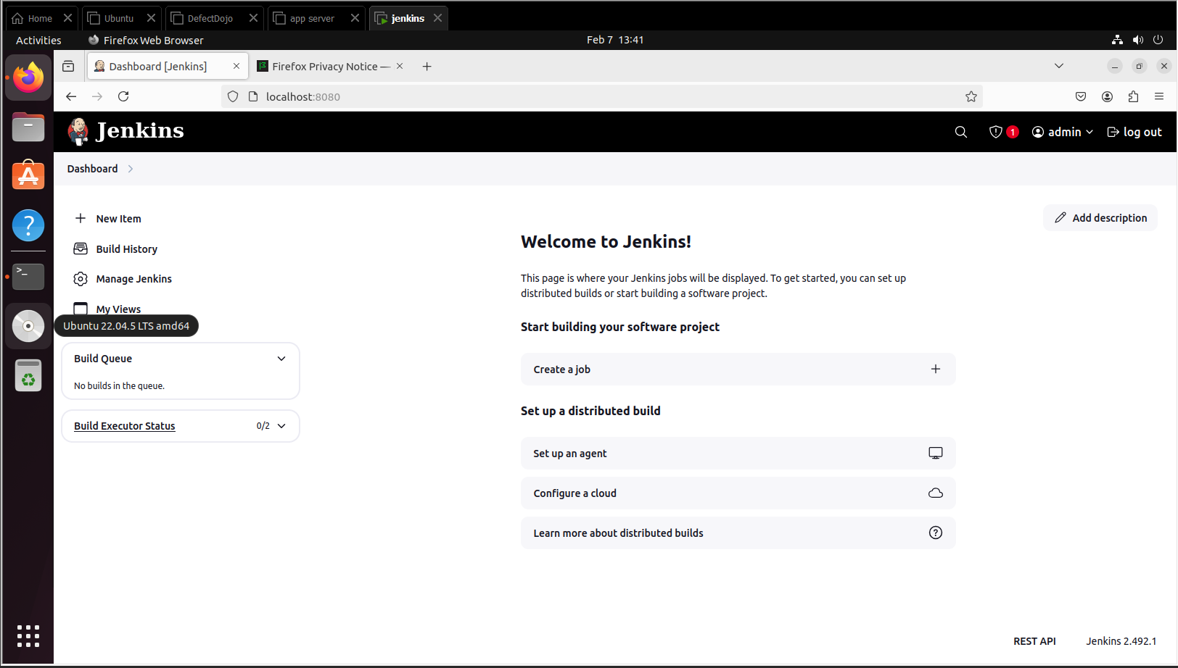  
Jenkins Dashboard

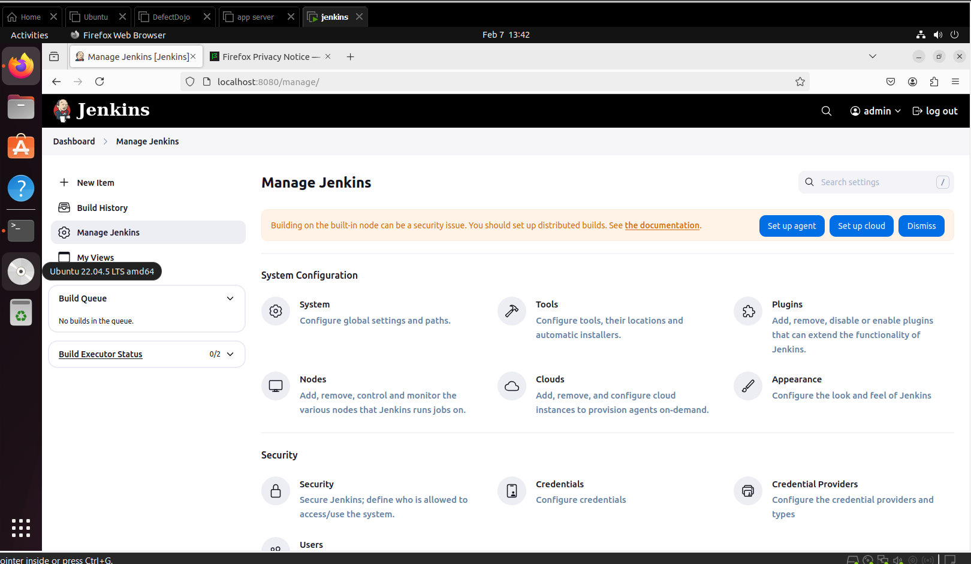  
Manage Jenkins 1

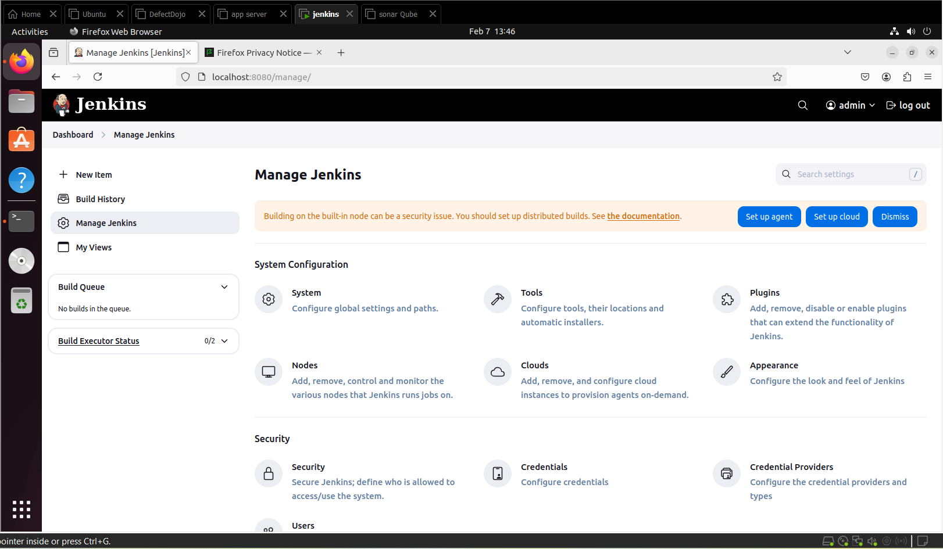  
Manage Jenkins 2

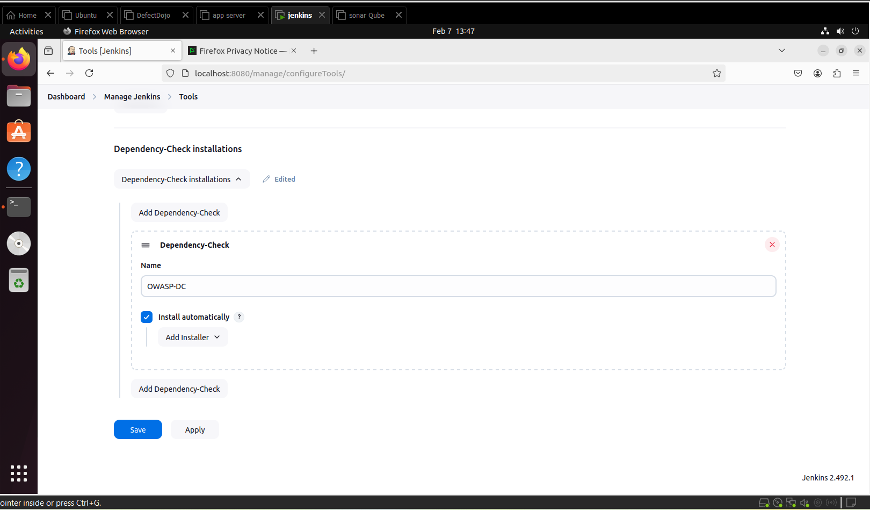  
Manage Jenkins: Tools

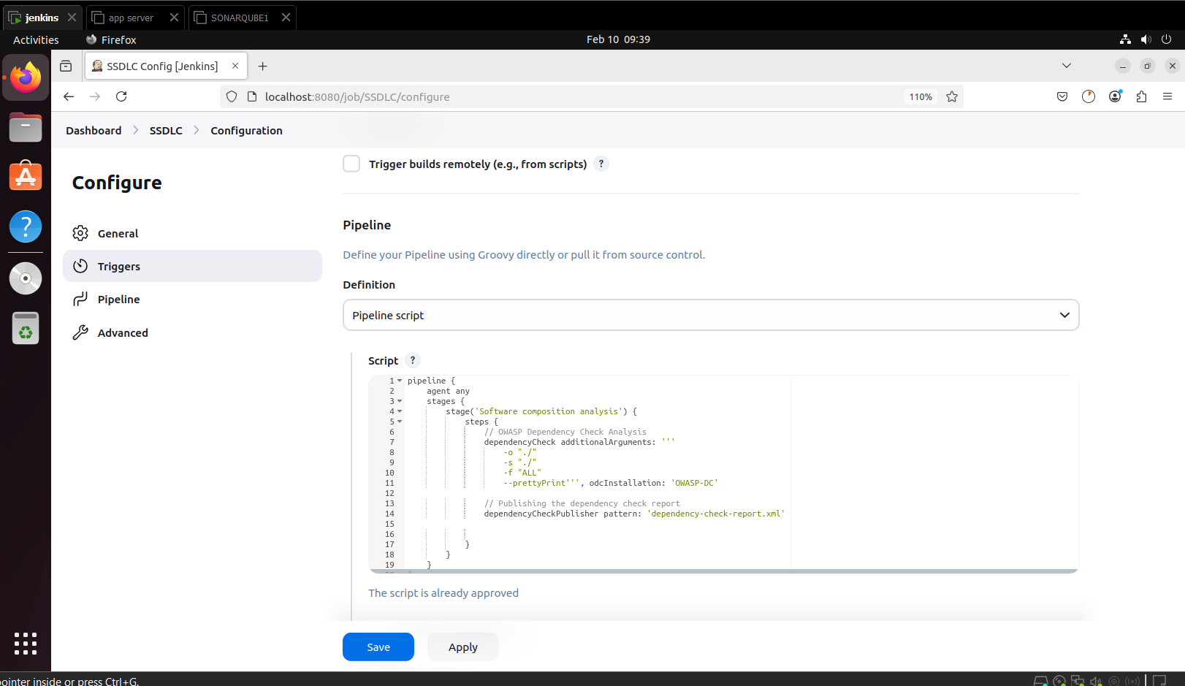  
Jenkins Pipeline 1

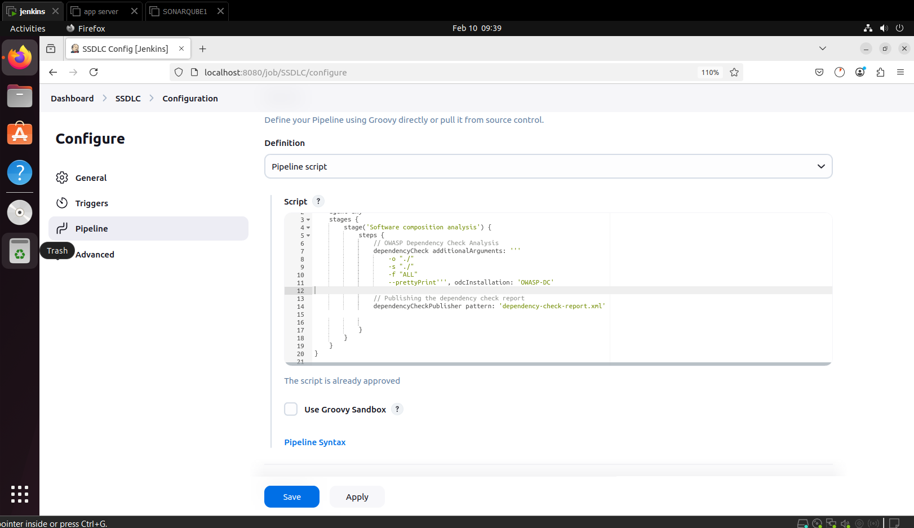  
Jenkins Pipeline 2

SonarQube Implementation:

|  |
| --- |
| **VM 2: SonarQube Server Setup**  SonarQube will perform static code analysis to identify code quality issues and vulnerabilities.  **Step 1: Install Docker (if using Docker for SonarQube)**   1. Install Docker on VM 2:    * On Debian/Ubuntu-based systems:   **sudo apt install docker.io**  **Step 2: Set Up SonarQube with Docker**   1. Pull the SonarQube Docker image:   **docker pull sonarqube**   1. Start SonarQube container:   **docker run -d -p 9000:9000 --name sonarqube sonarqube**  This will run SonarQube on port 9000 (http://<SonarQube-VM-IP>:9000).  **Step 3: Generate SonarQube API Token**   1. Log in to SonarQube and navigate to **My Account** > **Security**. 2. Generate a new API token and copy it for use in Jenkins (as configured in Step 3 of Jenkins setup).   **Step 4: Network Configuration**   1. Ensure VM 1 (Jenkins Server) can access SonarQube on port 9000. 2. Configure firewall rules if necessary to allow communication between Jenkins and SonarQube. |

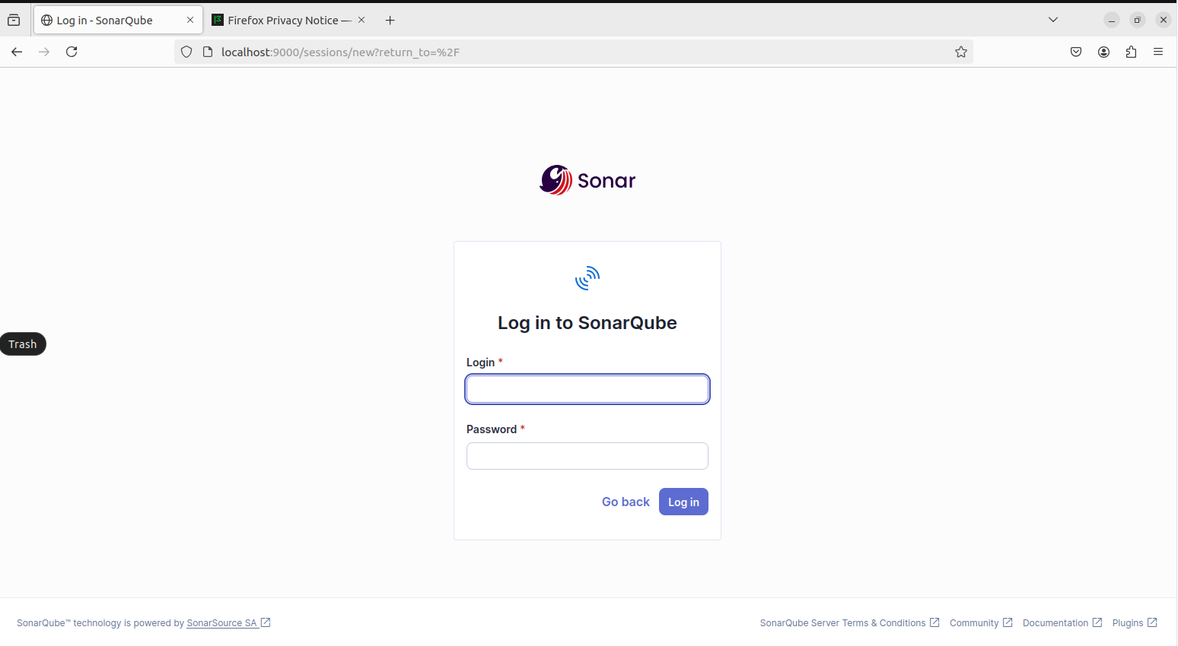  
SonarQube Login

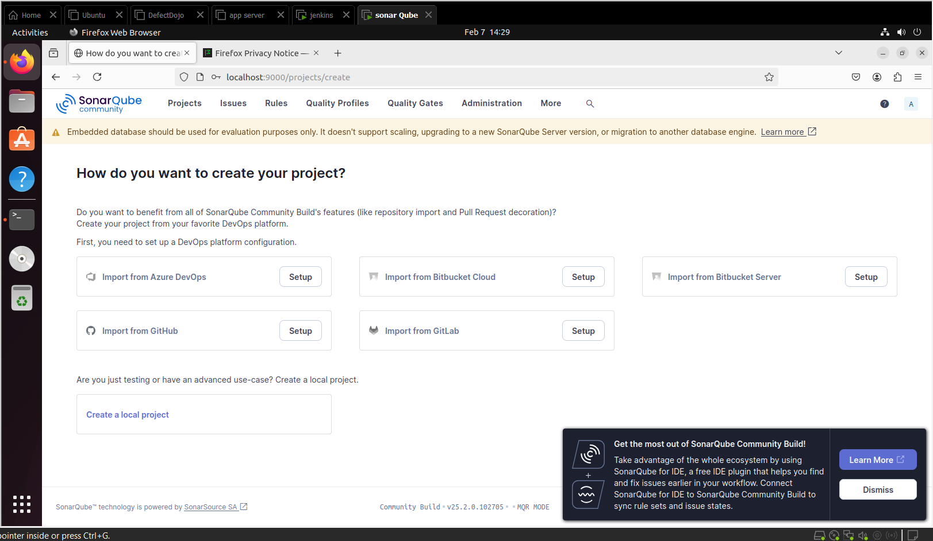  
SonarQube Dashboard

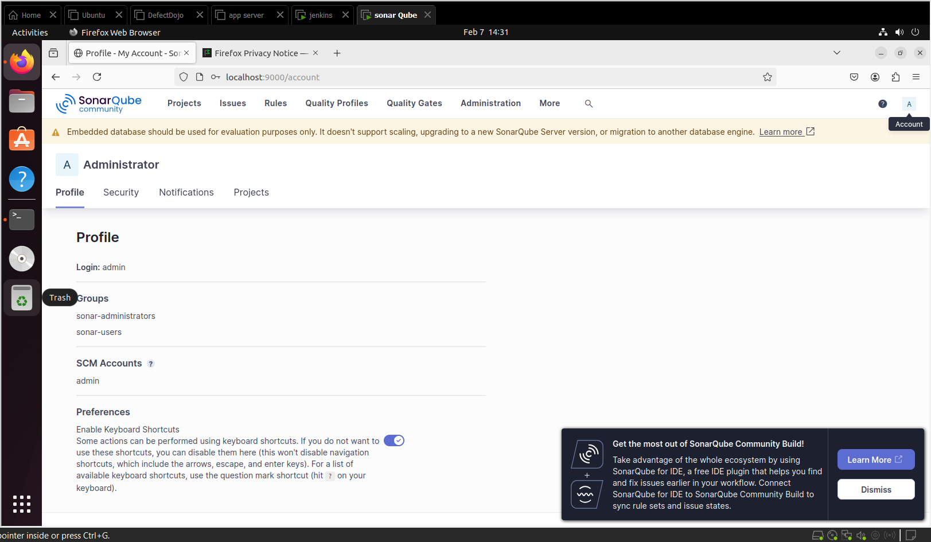  
SonarQube Admin setup 1

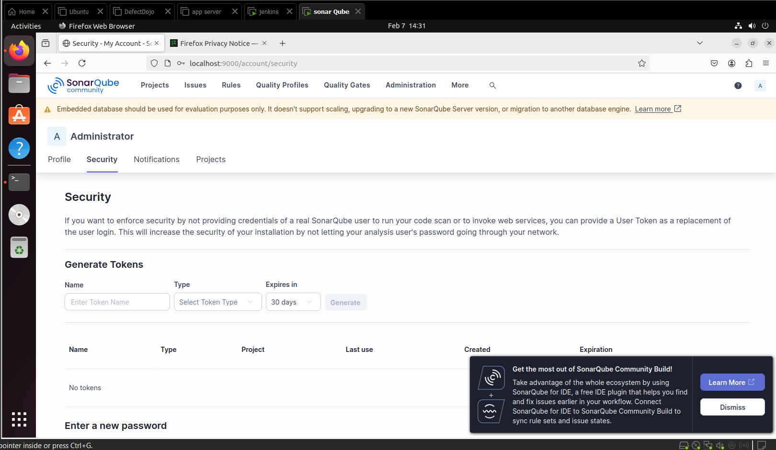  
SonarQube Admin setup 2 : Security

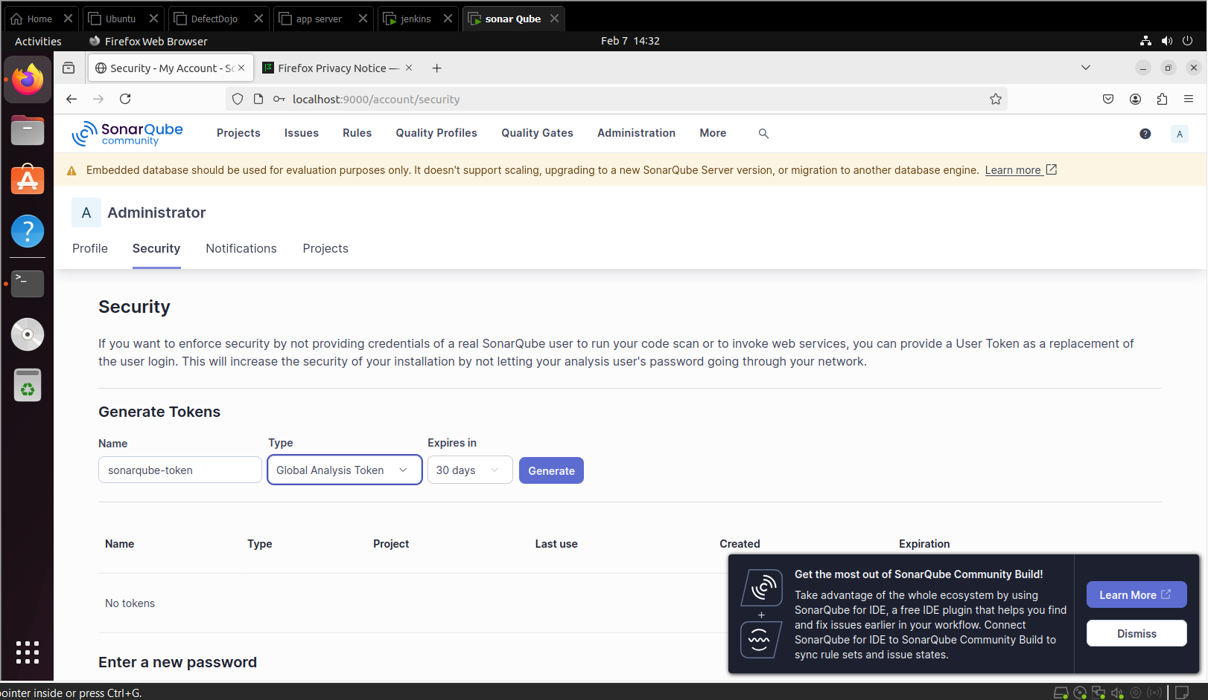  
SonarQube Admin setup 3 : Security

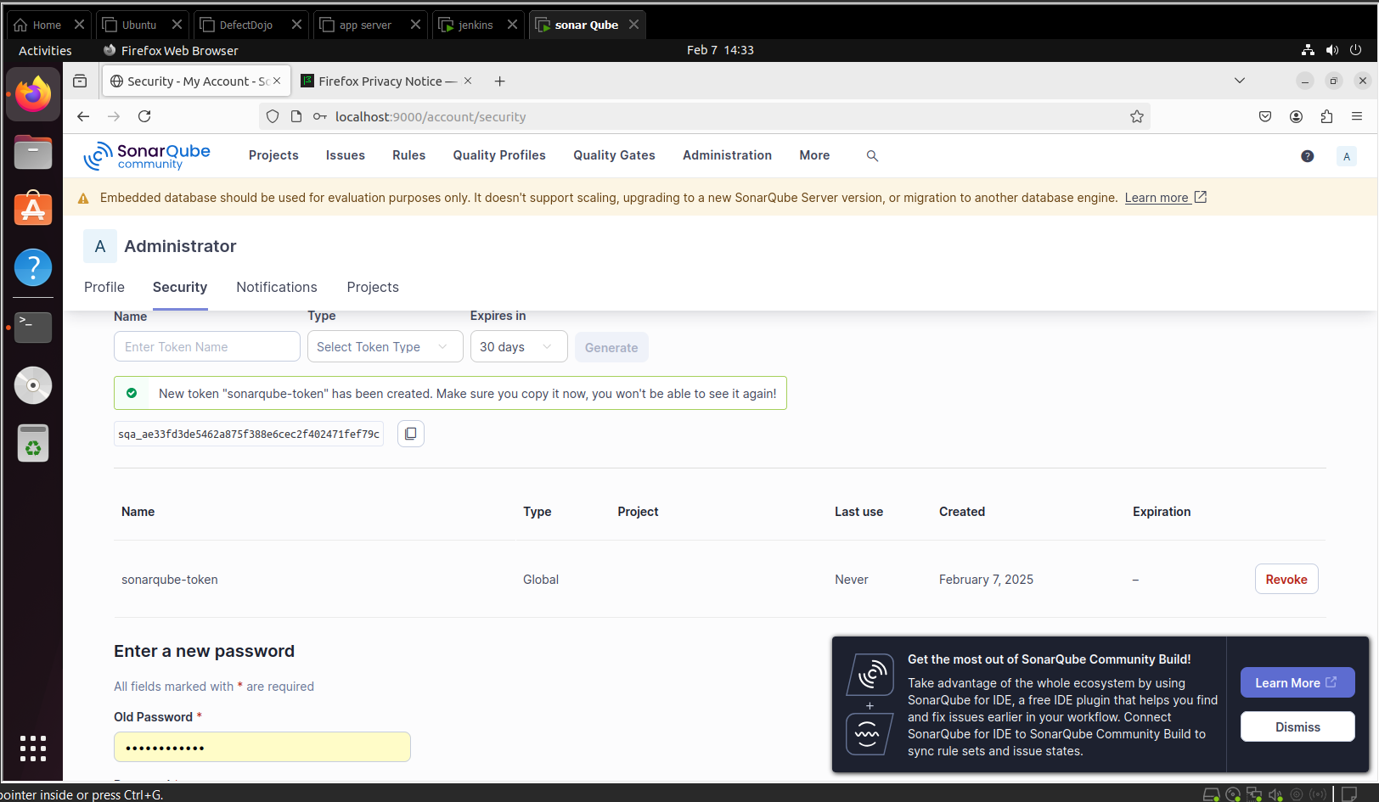  
SonarQube Security Key

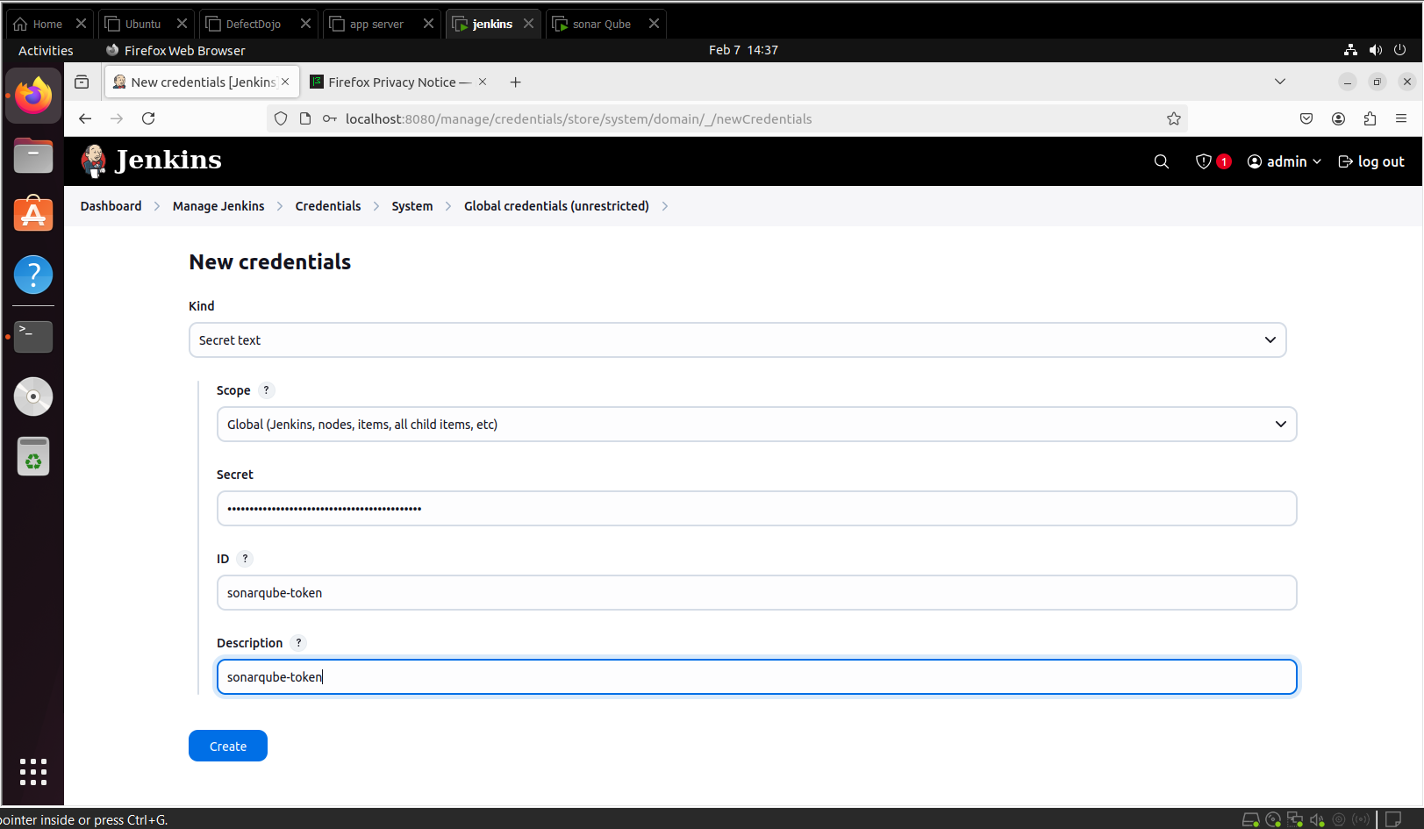  
Jenkins: SonarQube plugin setup 1

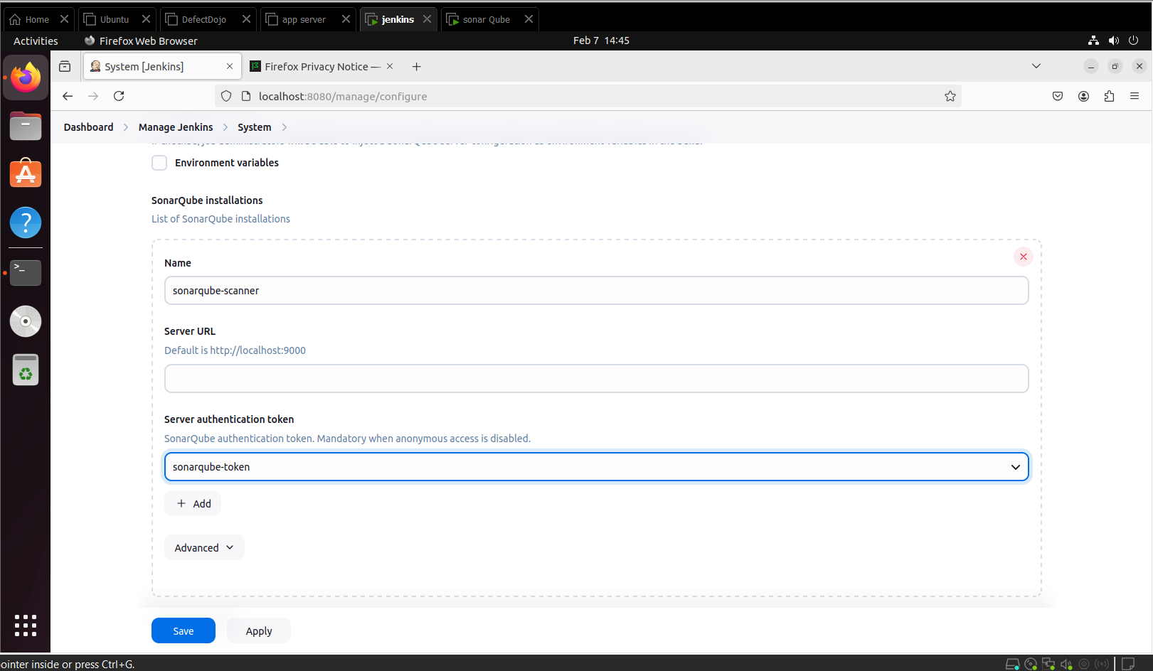  
Jenkins: SonarQube plugin setup 2

DefectDojo & Application Server implementation:

|  |
| --- |
| **VM 3: Application Server Setup**  This server will host the application and interact with both Jenkins for build/deployment tasks and DefectDojo for vulnerability management.  **Step 1: Install Docker (for OWASP ZAP and DefectDojo)**   1. Install Docker:   **sudo apt install docker.io**  **Step 2: Set Up OWASP ZAP**   1. Pull and run OWASP ZAP in Docker:   **docker pull owasp/zap2docker-stable**  **docker run -d -p 8080:8080 owasp/zap2docker-stable**  OWASP ZAP will run on port 8080.   1. **Integrate ZAP with Jenkins**:    * In Jenkins, configure the OWASP Dependency-Check Plugin or use scripts to trigger security scans via the ZAP API.   **Step 3: Set Up DefectDojo**   1. Clone the DefectDojo repository and set up using Docker Compose:   **git clone https://github.com/DefectDojo/django-DefectDojo.git**  **cd django-DefectDojo**  **docker-compose up**  DefectDojo will be accessible at port 8000 (http://<DefectDojo-VM-IP>:8000).   1. **Create Product and Engagements in DefectDojo**:    * Log into DefectDojo, create a new product (e.g., webgoat-devsecops), and set up an engagement linked to Jenkins. |

  
DefectDojo: Retrieve password

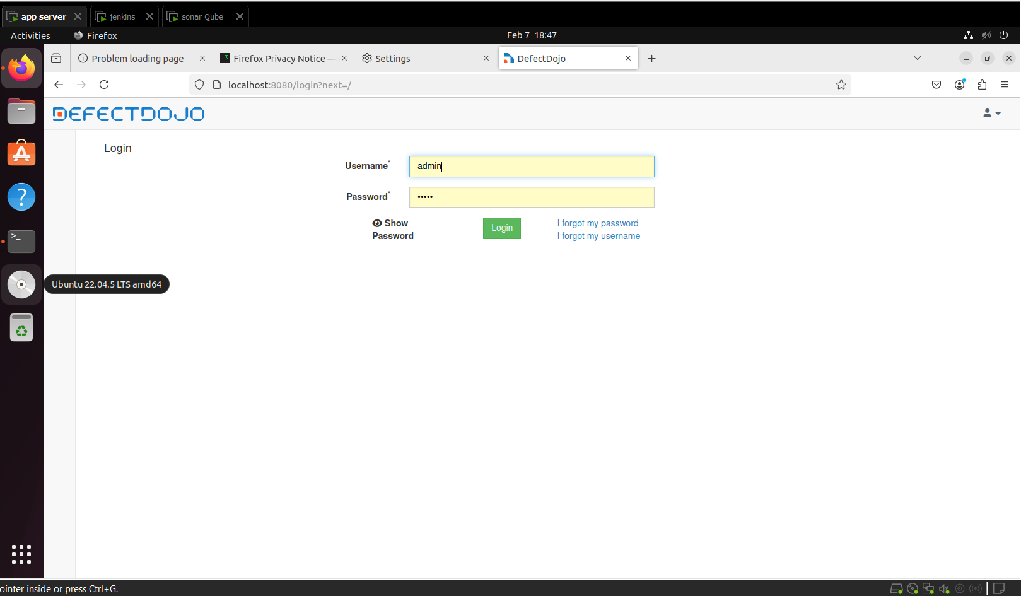  
DefectDojo login

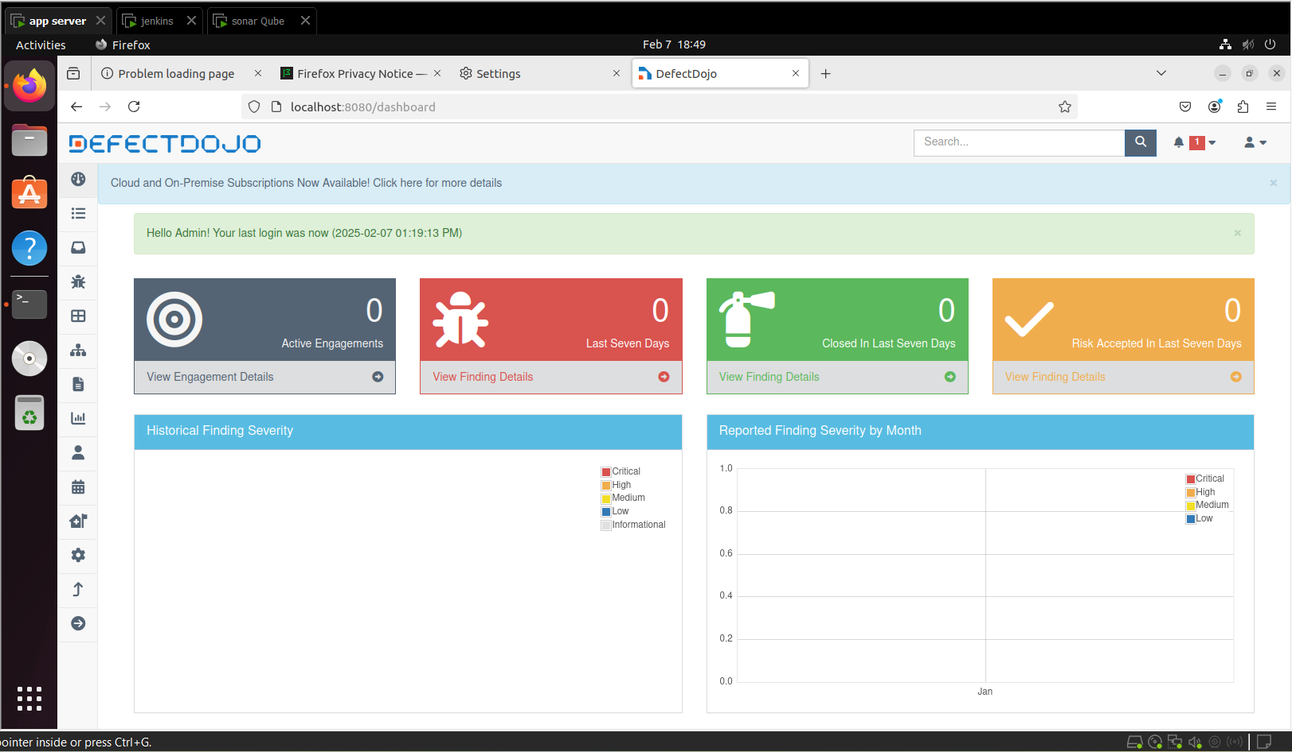  
DefectDojo Dashboard

Other configurations:

|  |
| --- |
| **Cross-VM Communication and Integration**  **Step 1: Configure Jenkins to Trigger Builds**   1. Jenkins will monitor the Git repository for changes. 2. When code is pushed, Jenkins triggers the build process.    * Build tools like Maven or Gradle are used to compile the code and create artifacts.   **Step 2: Trigger SonarQube Analysis**   1. After the build is completed, Jenkins triggers a SonarQube scan using the **SonarQube Scanner for Jenkins** plugin. 2. Jenkins communicates with the SonarQube server on VM 2 to perform static code analysis.   **Step 3: Trigger OWASP ZAP Security Scan**   1. After SonarQube analysis, Jenkins triggers an OWASP ZAP security scan via API. ZAP scans the application hosted on VM 3. 2. The results of the ZAP scan are saved and sent to DefectDojo.   **Step 4: Push Results to DefectDojo**   1. After both SonarQube and ZAP scans, Jenkins sends the results to DefectDojo (VM 3) via the DefectDojo API. 2. Vulnerabilities from SonarQube and ZAP are tracked and reported in DefectDojo, giving teams a centralized view of all vulnerabilities. |
| **CI/CD Pipeline Flow Summary**   1. **Developer Pushes Code**:    * Developer commits and pushes code to a Git repository. 2. **Jenkins Build**:    * Jenkins detects the push and starts the build process. 3. **Static Code Analysis (SonarQube)**:    * Jenkins triggers SonarQube to perform static code analysis on the built code.    * SonarQube checks for code quality issues and vulnerabilities. 4. **Security Scanning (OWASP ZAP)**:    * Jenkins triggers OWASP ZAP to scan the running application for dynamic vulnerabilities.    * ZAP checks for security flaws like XSS, SQL injection, etc. 5. **Vulnerability Tracking (DefectDojo)**:    * Jenkins pushes the results from SonarQube and ZAP to DefectDojo.    * DefectDojo manages the vulnerabilities, allowing teams to track remediation efforts and prioritize fixes. |
| **Security Considerations**   1. **SSH Key Authentication**:    * Use SSH keys for secure communication between Jenkins (VM 1) and the application server (VM 3). 2. **API Tokens**:    * Ensure API tokens (for SonarQube and DefectDojo) are securely stored in Jenkins credentials. 3. **Network Security**:    * Ensure that the VMs are securely configured and have the necessary firewall rules for communication. |

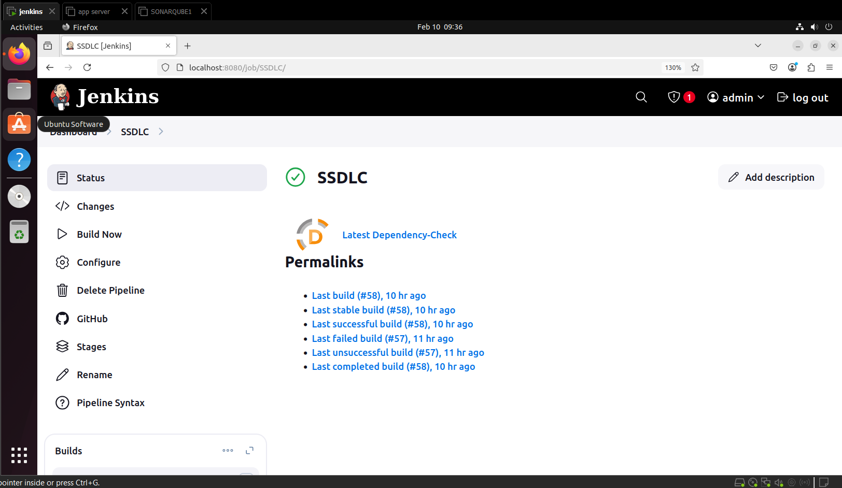  
Jenkins: Dependency Check

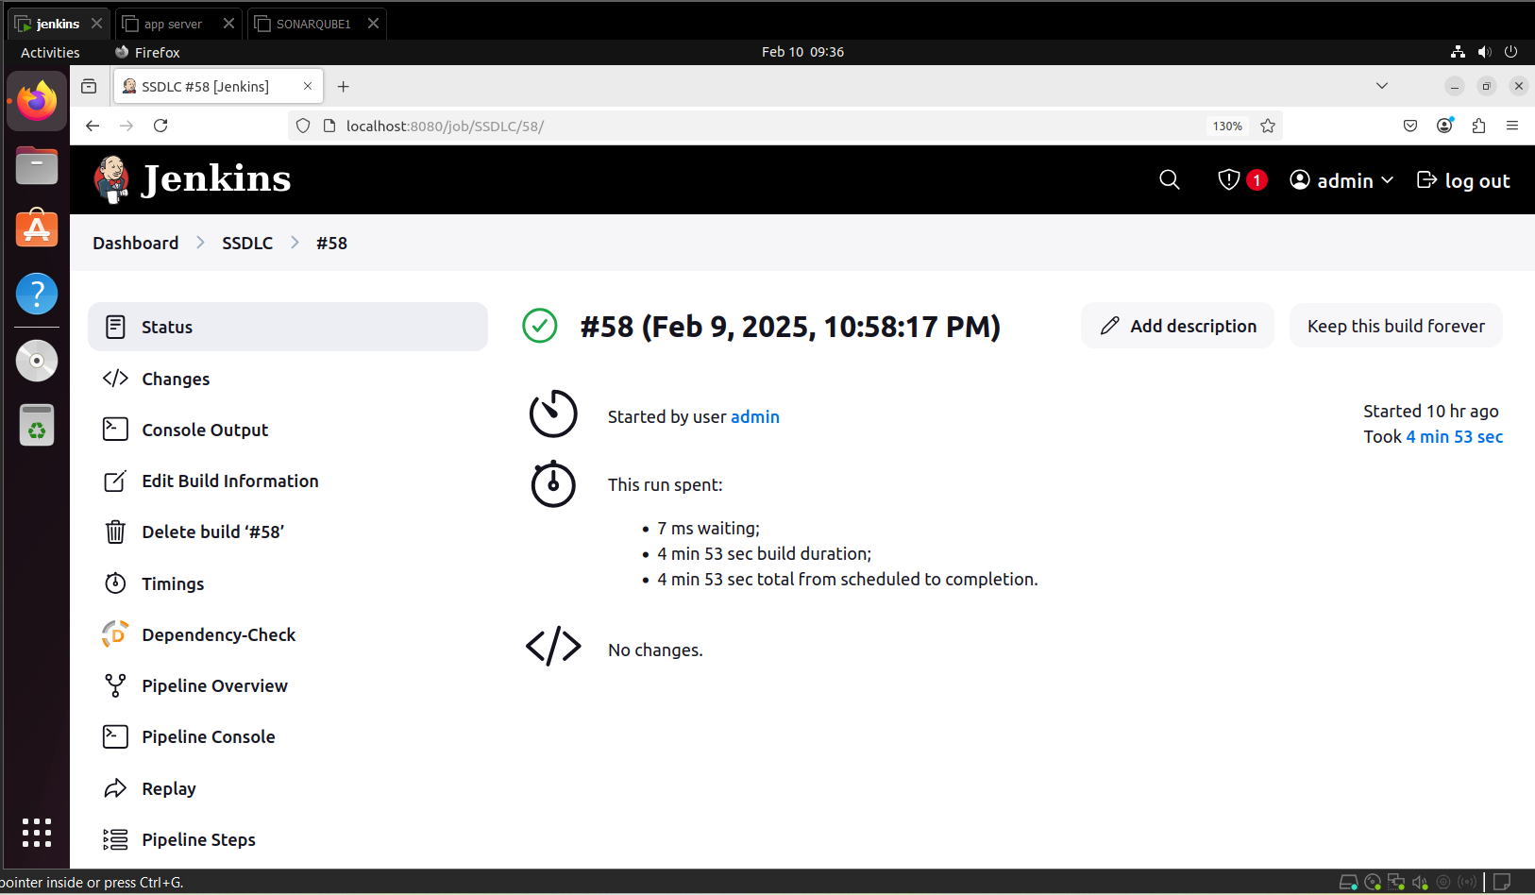  
Jenkins: Successful Build

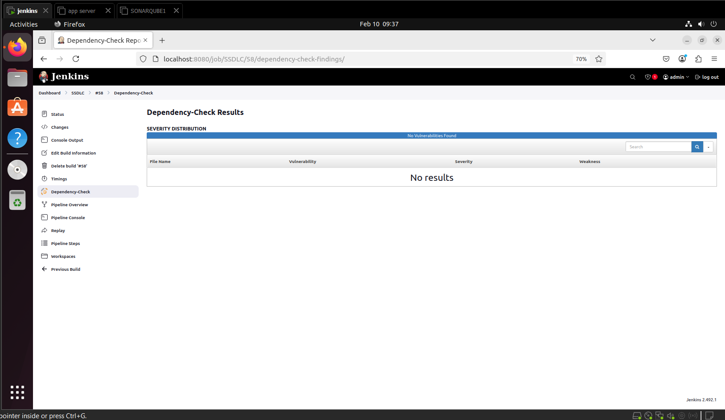  
Dependency Check Results 1

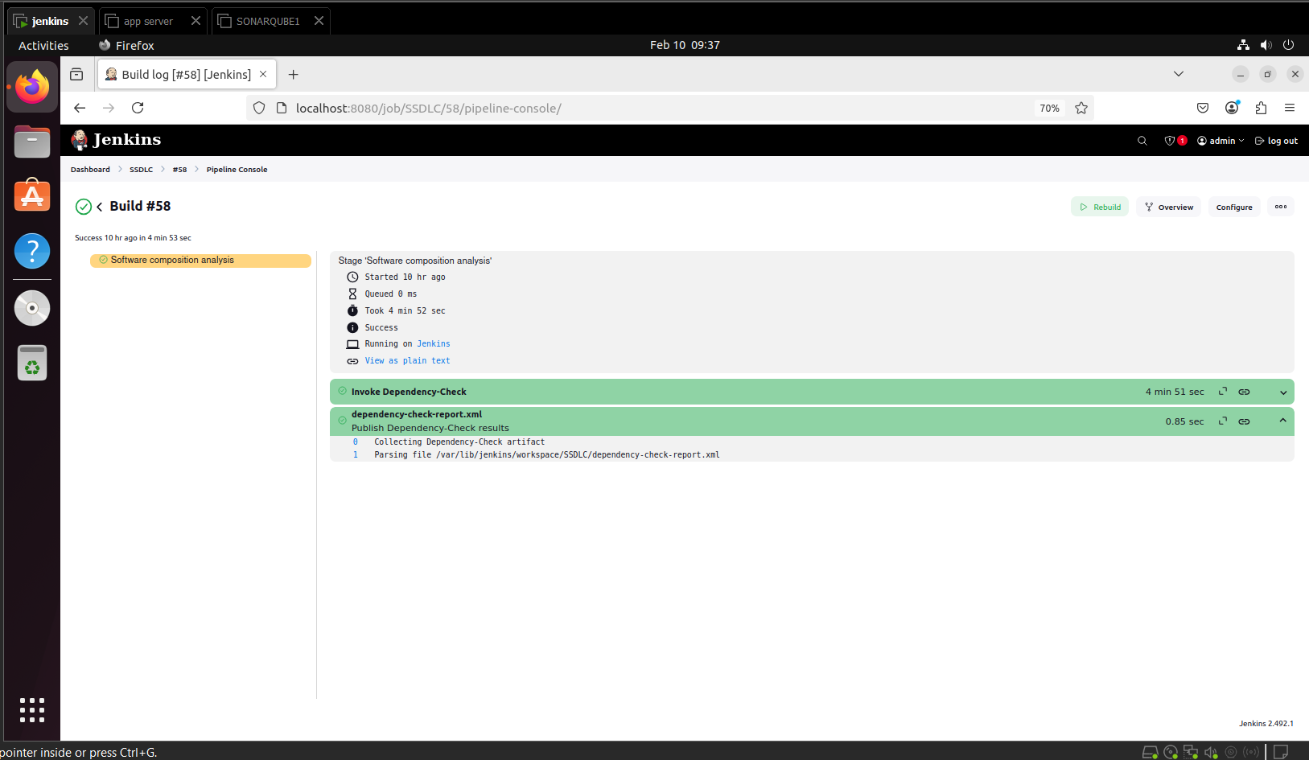  
Dependency Check Results 2

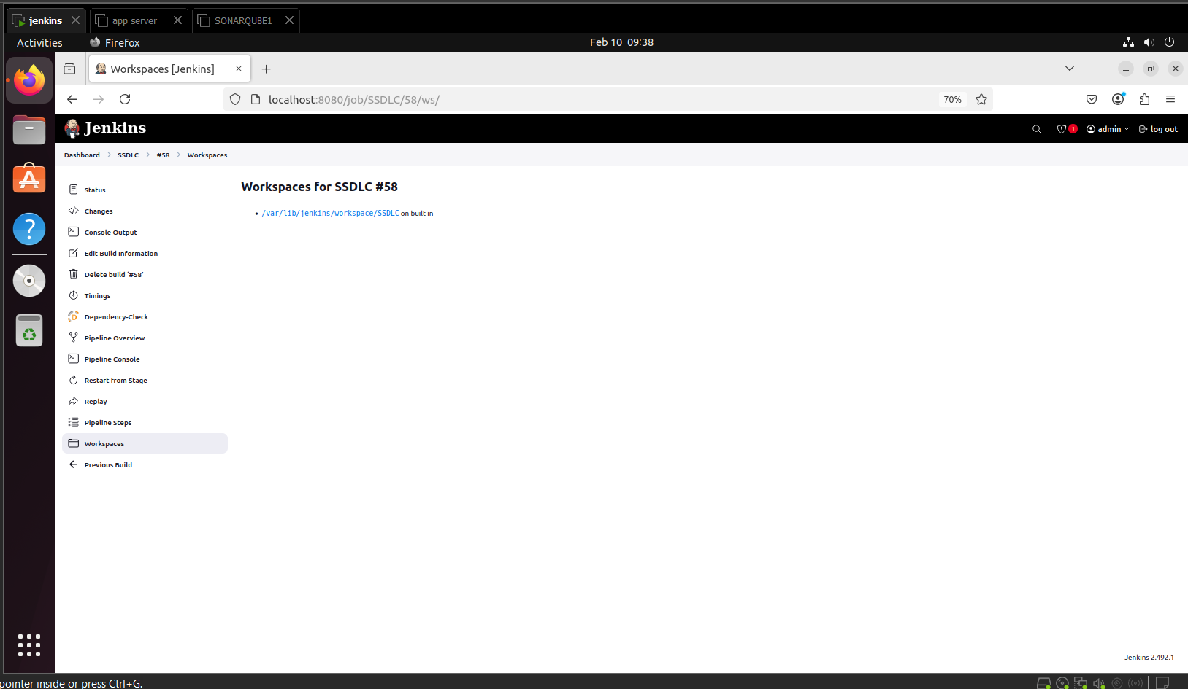  
Results saved in Workspace 1

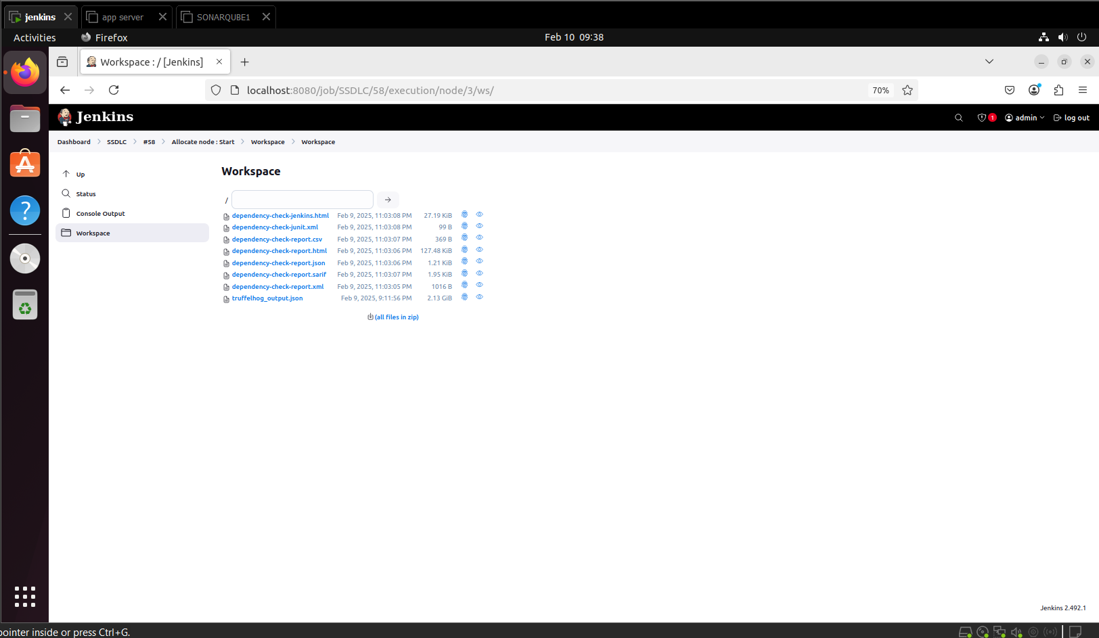  
Results saved in Workspace 2

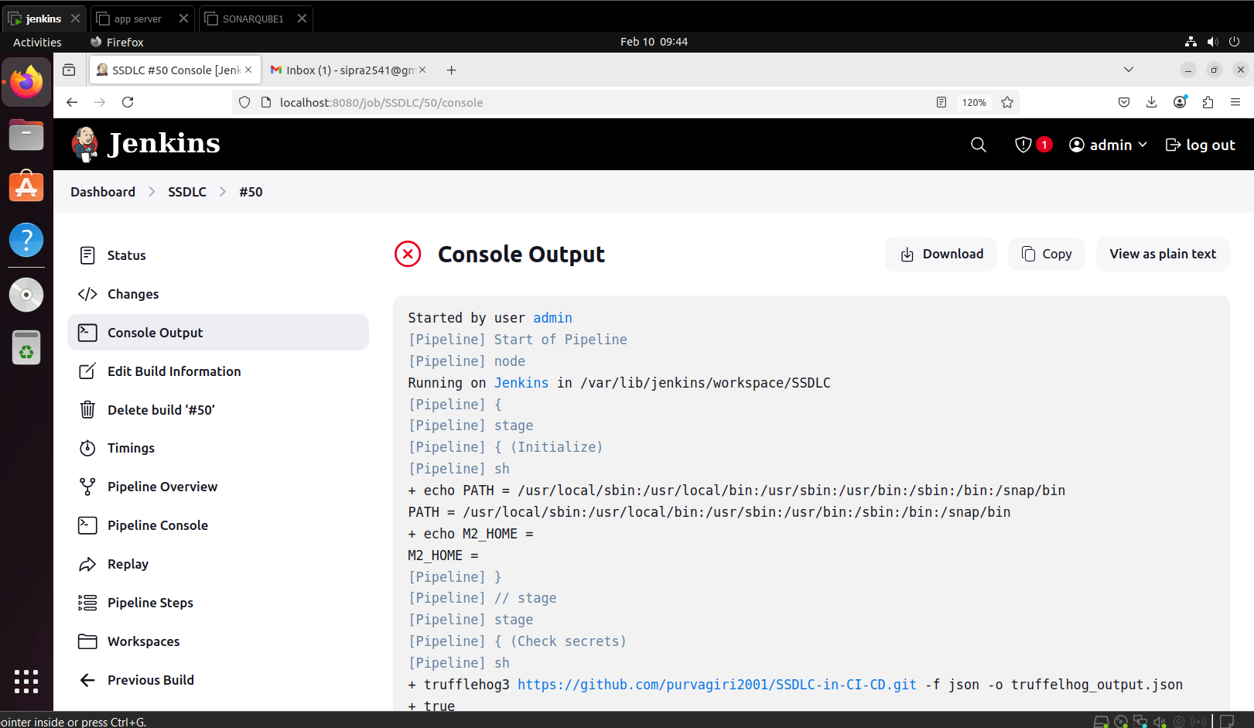  
Trufflehog Build Output 1

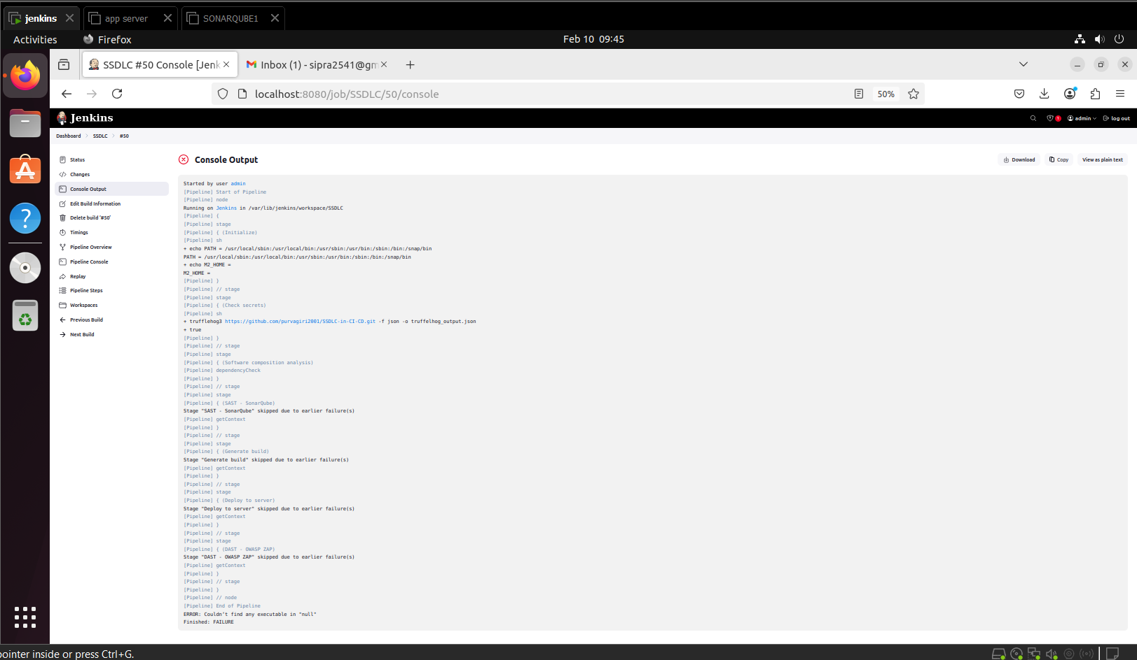  
Trufflehog Build Output 2

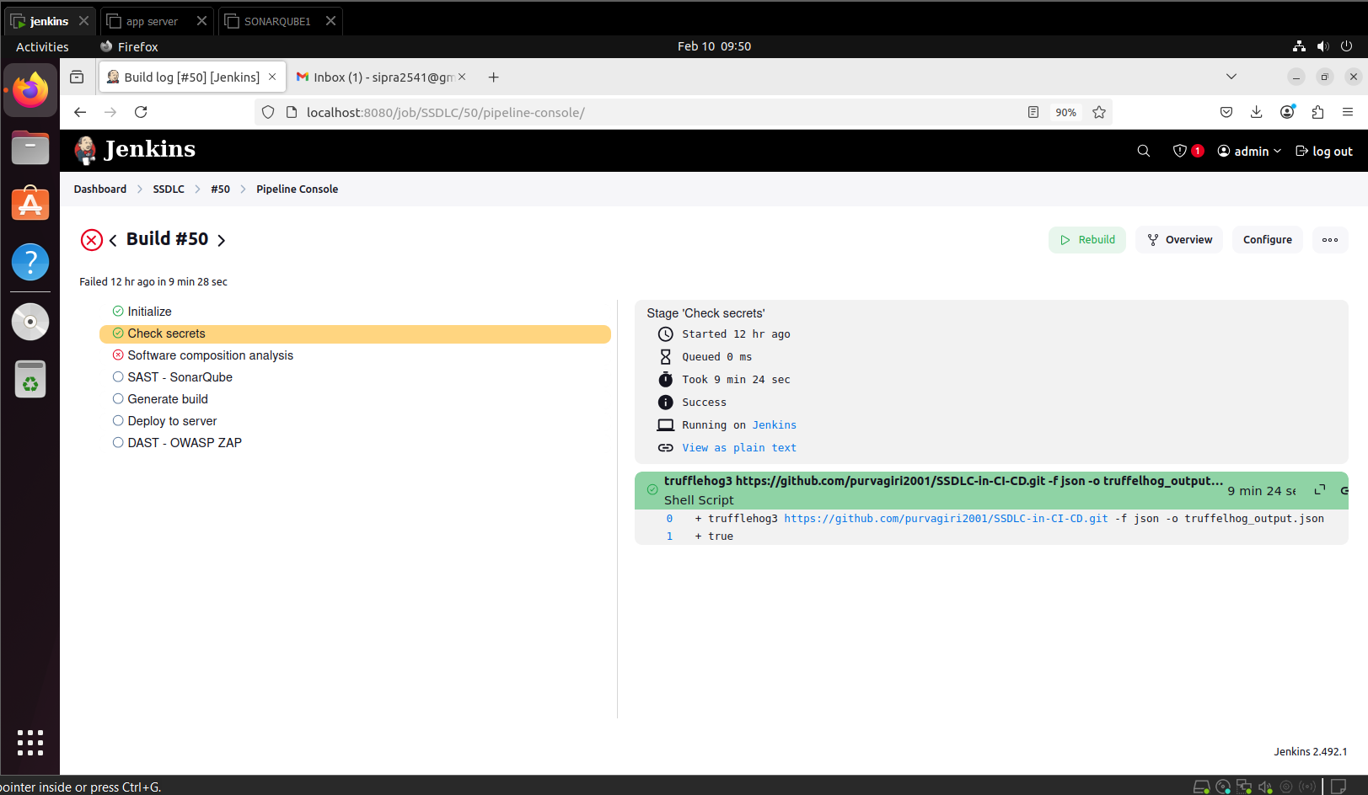  
Trufflehog Build Output 3

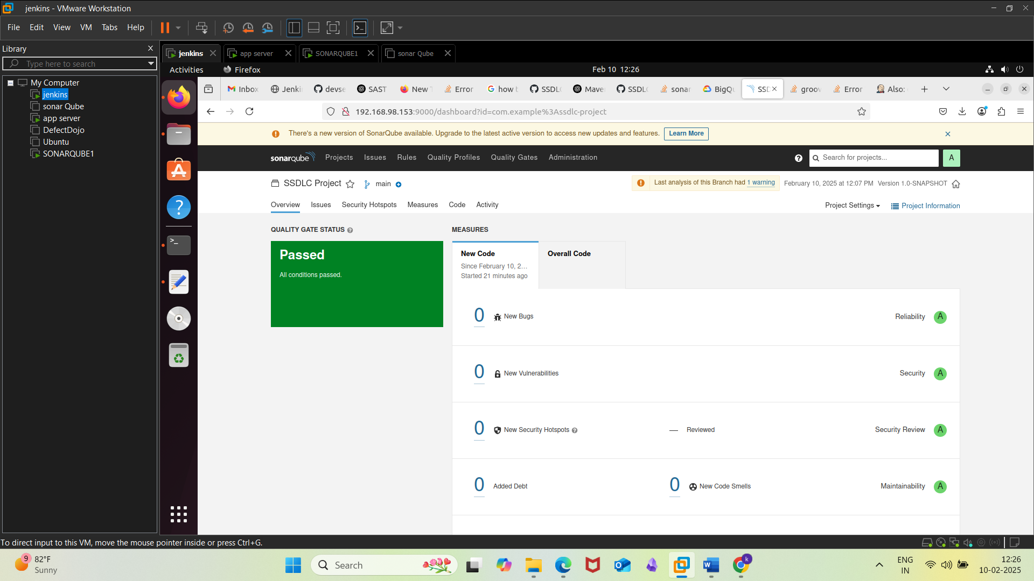  
SonarQube Scan

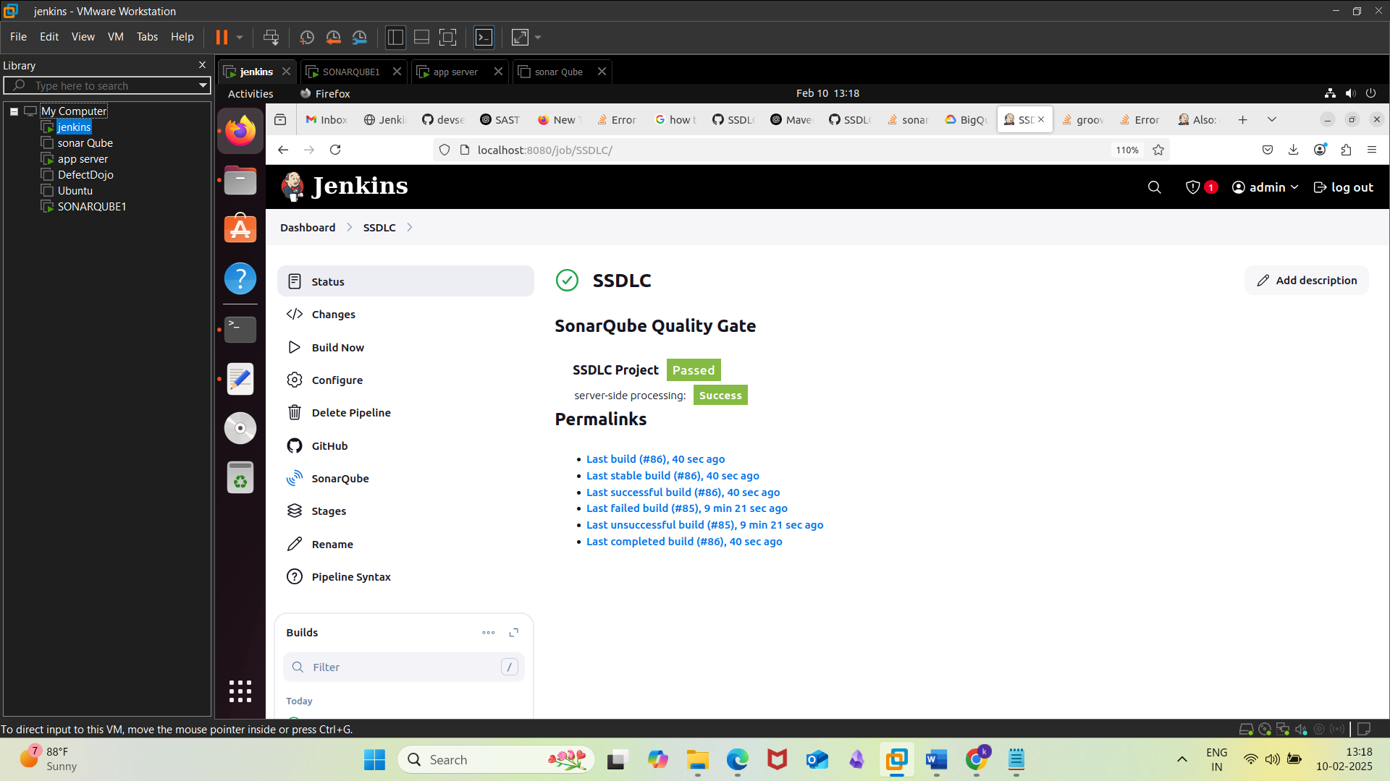  
Jenkins Successful Final Build 1

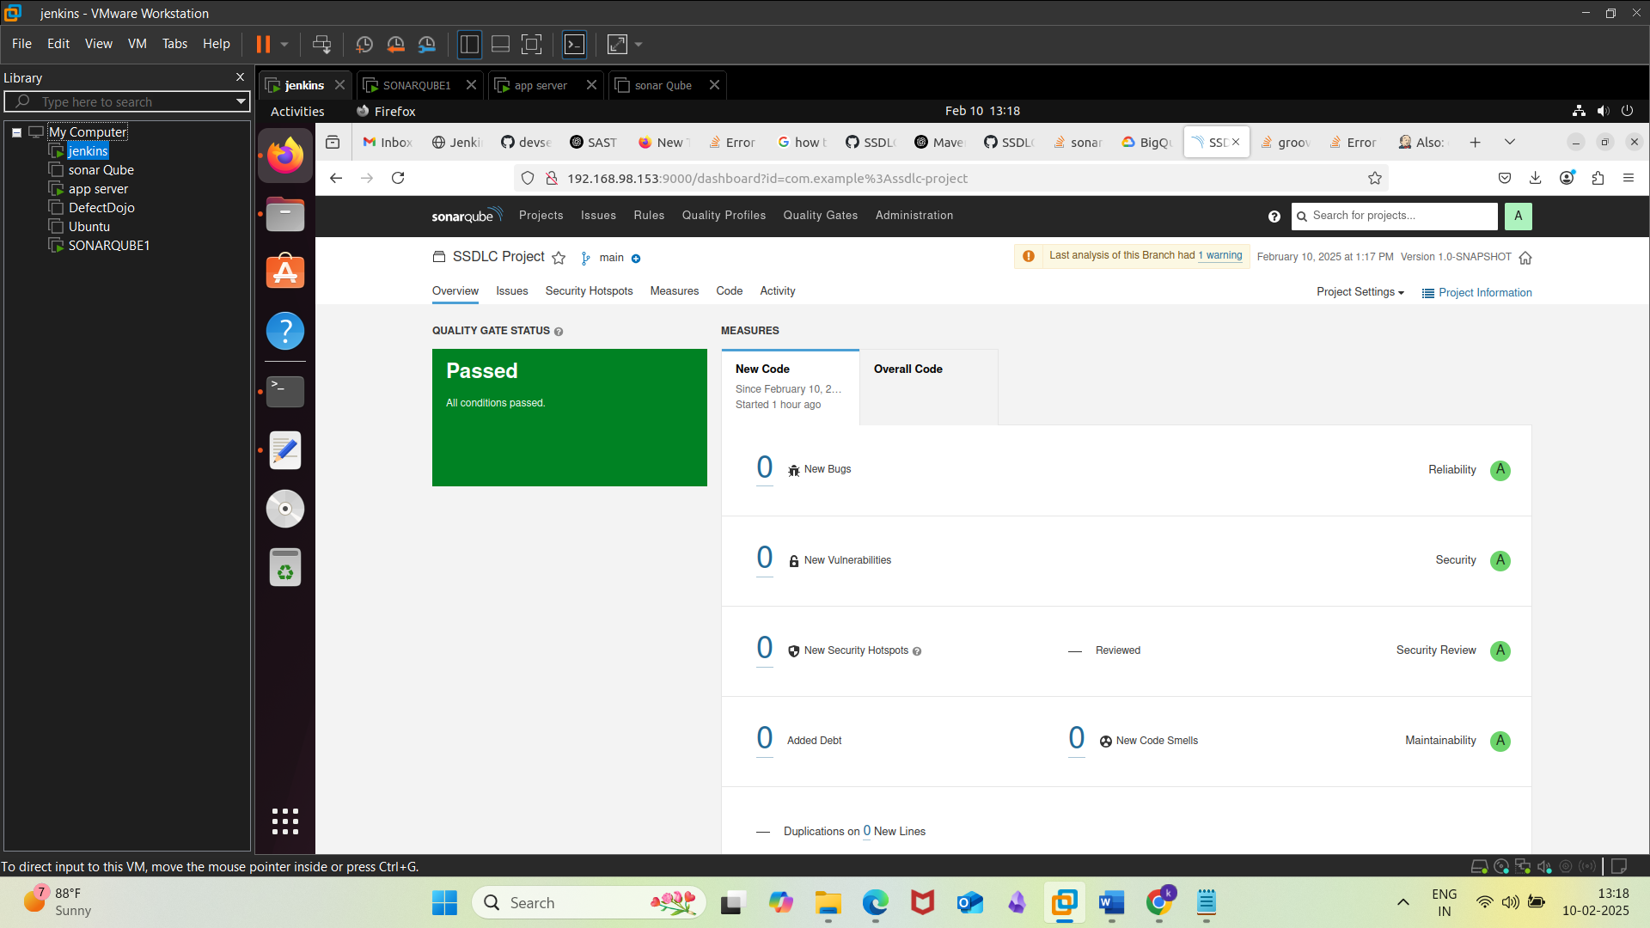  
SonarQube Scan 2

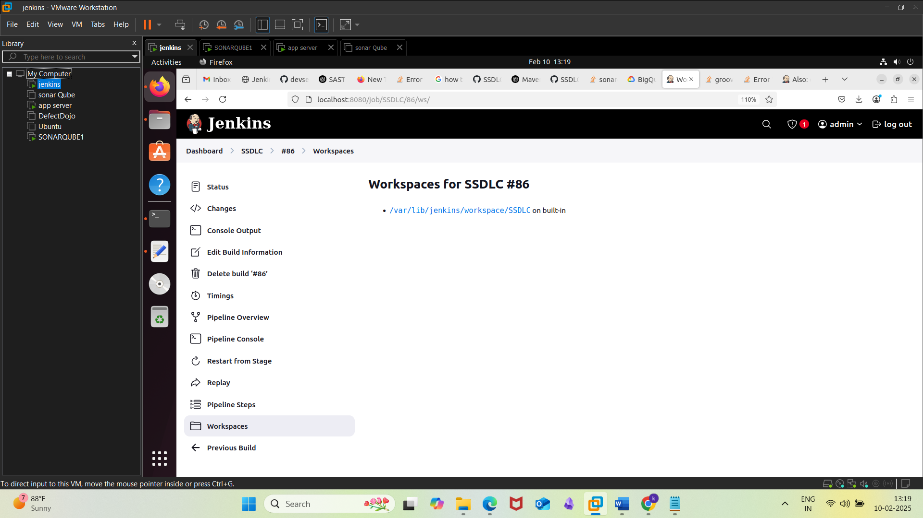  
Jenkins Build result saved in Workspace

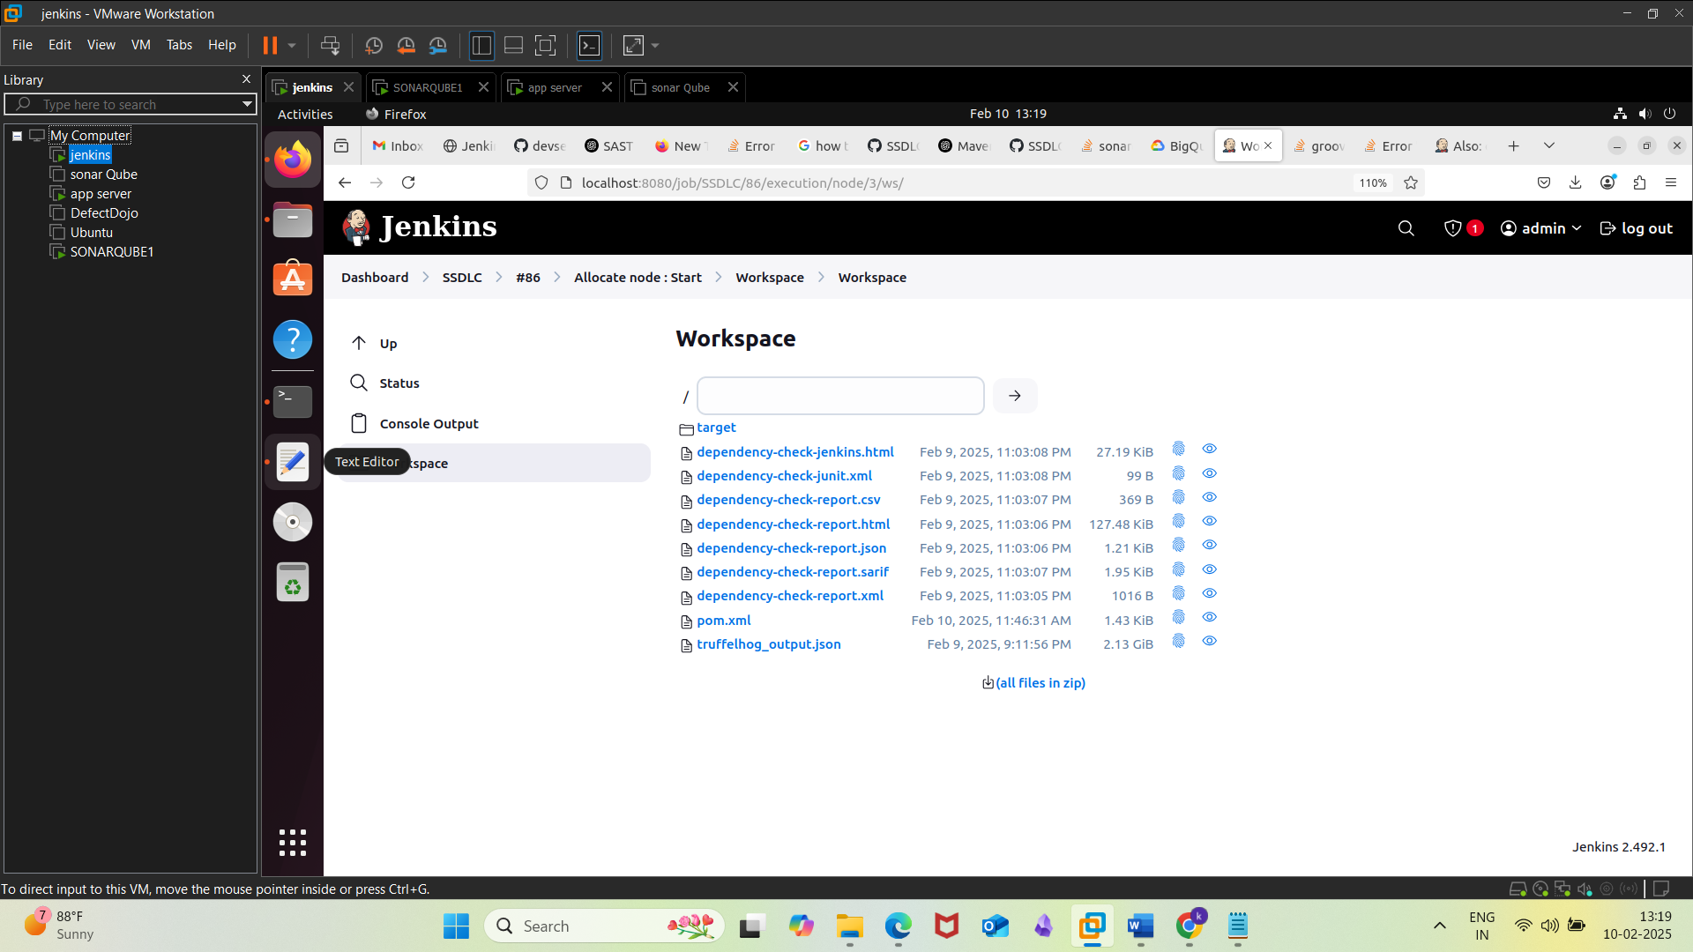  
Workspace Files

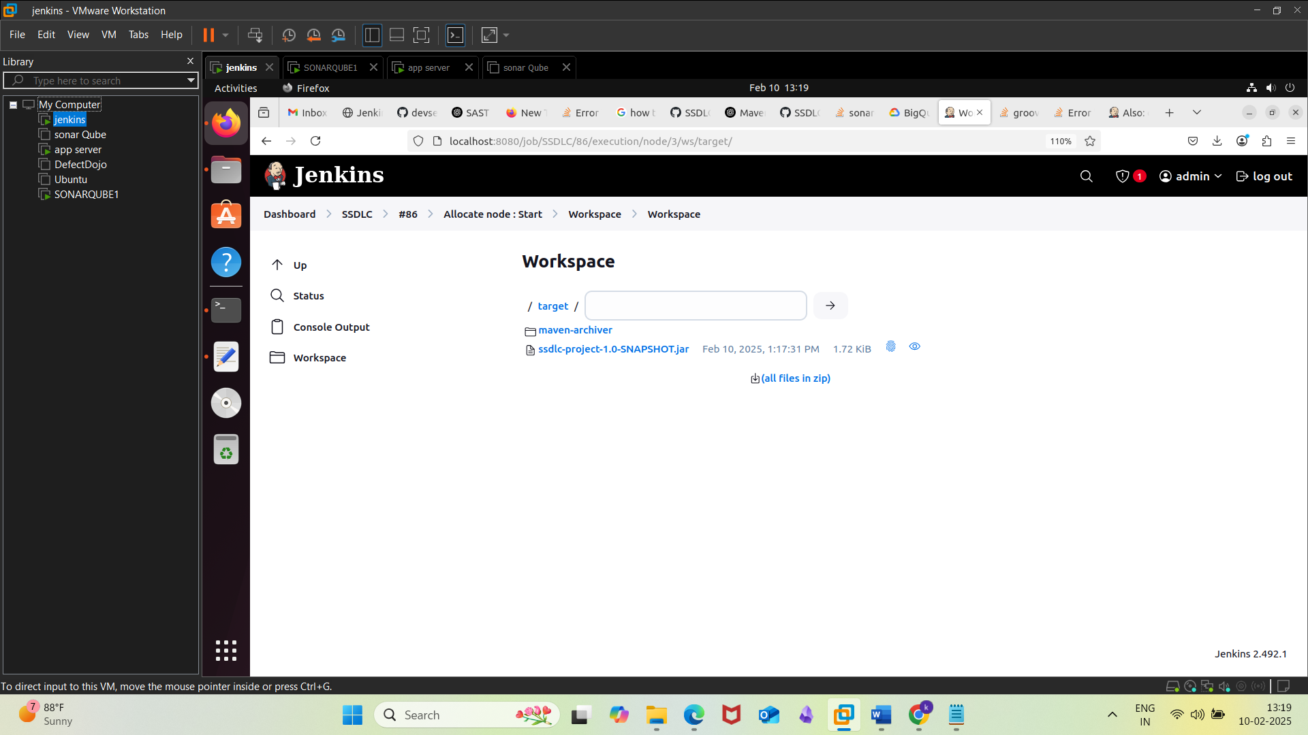  
Workspace files and archives of Maven

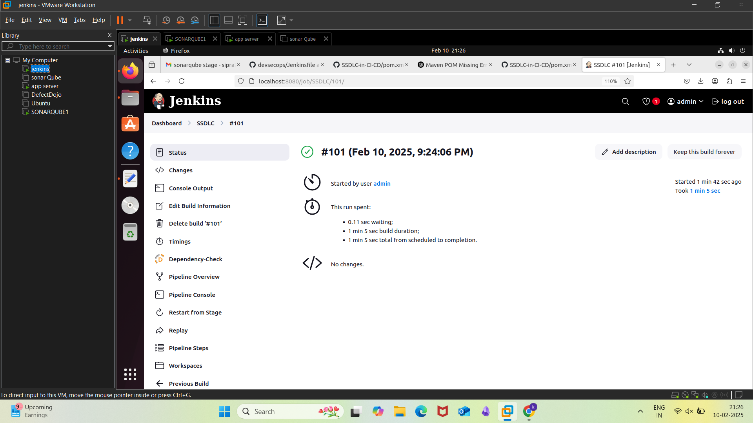  
Successful Build

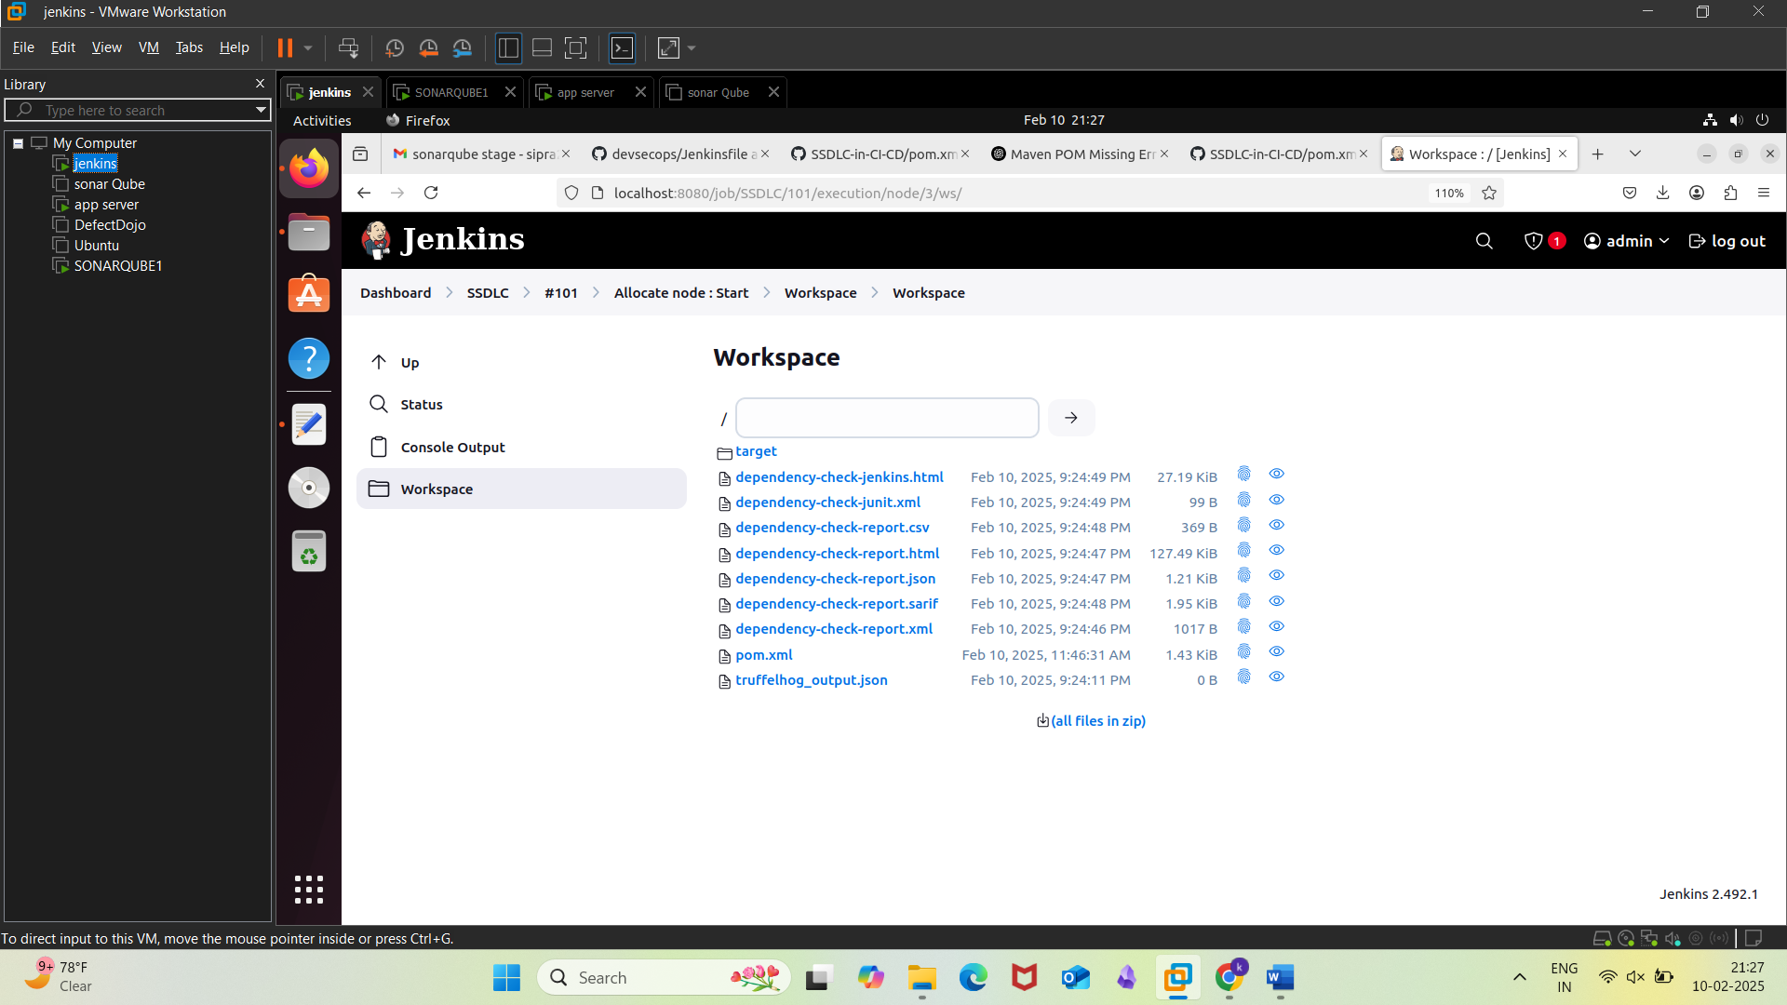  
Results in Workspace in next iteration

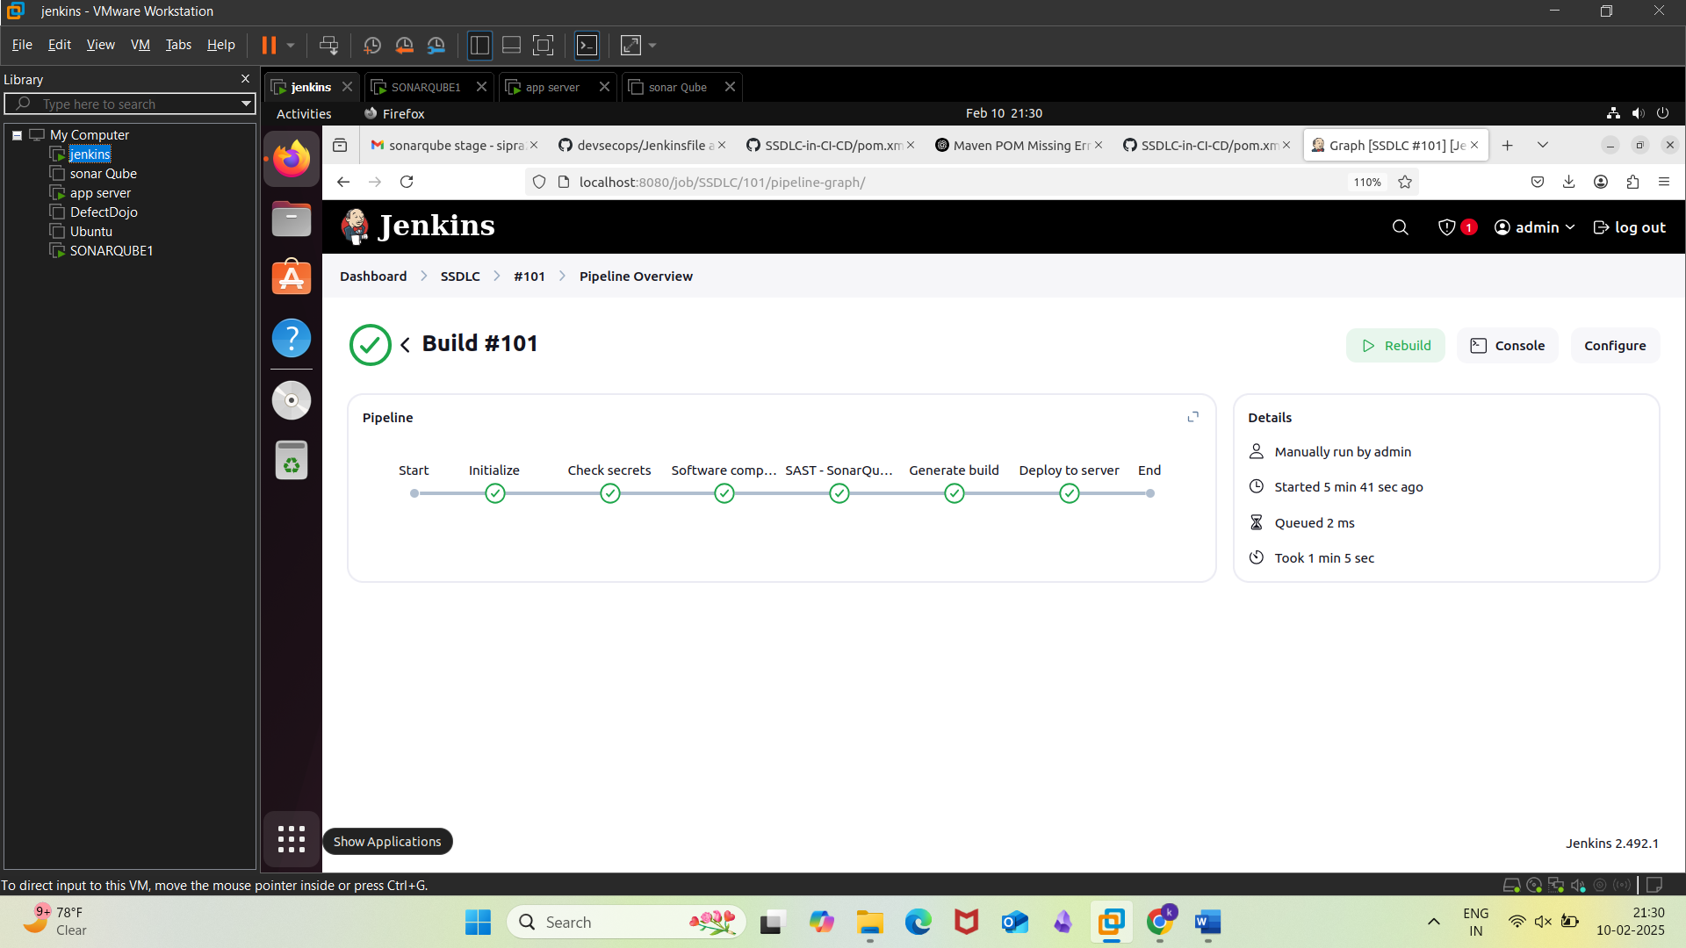  
Successful Build

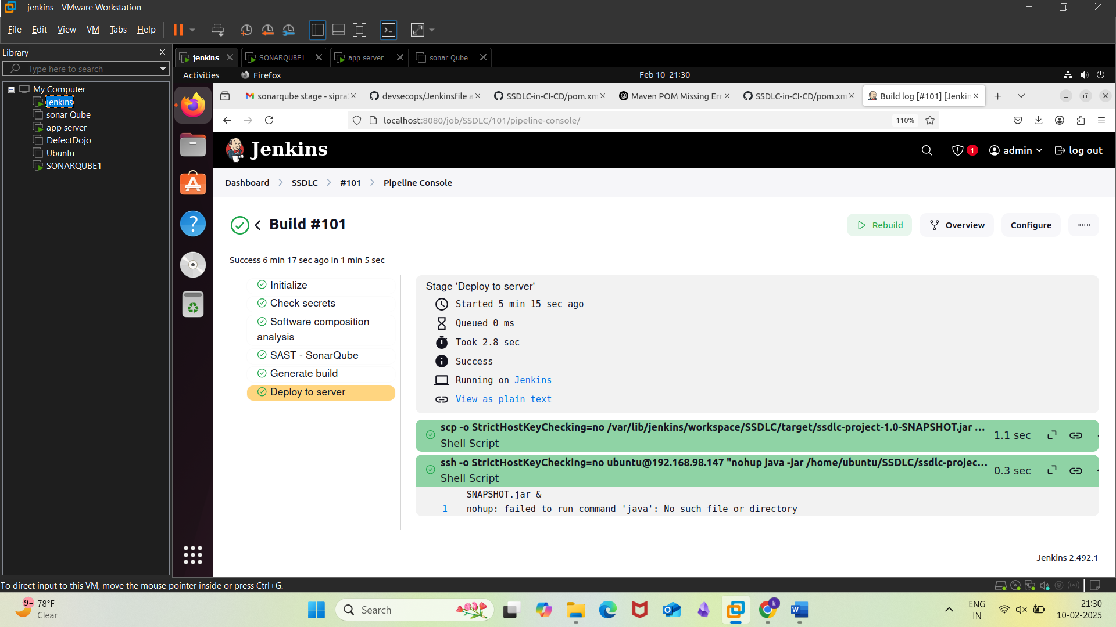  
Output in the pipeline console

**CONCLUSION**

The project aims to automate and secure the entire software development lifecycle by implementing a comprehensive DevSecOps pipeline. This pipeline includes tools like Jenkins, SonarQube, OWASP ZAP, DefectDojo, and keyless SSH. Jenkins is the central automation server, allowing for automatic execution of tasks like code builds, unit and integration testing, and static code analysis. This reduces manual intervention and helps identify issues early in the development cycle. Security and quality assurance are also integrated into the pipeline, with SonarQube providing static code analysis to detect vulnerabilities and maintainability concerns. OWASP ZAP adds dynamic security testing, identifying vulnerabilities during runtime. DefectDojo acts as a centralized vulnerability management tool, aggregating results from SonarQube and OWASP ZAP.   
Keyless SSH ensures seamless communication between Jenkins, SonarQube, and application servers, enhancing automation, security, and speeding up the process. The pipeline also integrates between various tools and systems, with Jenkins triggering SonarQube scans and OWASP ZAP security tests automatically after each code commit. This ensures a consistent and unified approach to managing the entire development process, from code quality to security.

**REFERENCES**

1. **Jenkins Official Documentation**: Jenkins. (n.d.). Jenkins User Documentation. <https://www.jenkins.io/doc/>
2. **SonarQube Official Documentation**: SonarSource. (n.d.). SonarQube Documentation. <https://docs.sonarqube.org/latest/>
3. **OWASP ZAP Official Documentation**: OWASP Foundation. (2020). ZAP Documentation. <https://www.zaproxy.org/docs/>
4. **OWASP ZAP Docker Setup**: OWASP Foundation. (n.d.). ZAP Docker Images. <https://www.zaproxy.org/docs/docker/>
5. **DefectDojo Official Documentation**: DefectDojo. (2021). DefectDojo Documentation. <https://defectdojo.github.io/django-DefectDojo/>
6. **SSH Keyless Authentication**: Stack Overflow. (2019). How to Set Up Keyless SSH Authentication. <https://stackoverflow.com/questions/2740425/how-to-setup-ssh-without-password>
7. **SonarQube and Jenkins Integration**: SonarSource. (2020). Integrating Jenkins with SonarQube. <https://docs.sonarqube.org/latest/analysis/jenkins/>
8. **Apache Maven Documentation**: Apache Software Foundation. (2020). Maven Project. <https://maven.apache.org/>
9. **TruffleHog3 GitHub Repository**: TruffleHog. (2021). TruffleHog3: Find Secrets in Git Repositories. <https://github.com/trufflesecurity/trufflehog>
10. **Docker Official Documentation**: Docker. (n.d.). Docker Documentation. <https://docs.docker.com/>
11. **OWASP ZAP Integration with Jenkins**: OWASP Foundation. (2021). Automating ZAP with Jenkins. <https://www.zaproxy.org/docs/jenkins/>
12. **Keyless SSH Setup**: DigitalOcean. (2020). How to Set Up SSH Key-Based Authentication on a Linux Server. <https://www.digitalocean.com/community/tutorials/how-to-set-up-ssh-key-based-authentication-on-a-linux-server>
13. **Jenkins Pipelines and SonarQube**: Jenkins.io. (2019). Integrating SonarQube with Jenkins Pipelines. <https://www.jenkins.io/blog/2019/02/19/sonarqube-integration-in-pipelines/>
14. **DefectDojo - API Scanning Integration**: DefectDojo. (2021). How to Integrate with API Security Tools. <https://defectdojo.github.io/django-DefectDojo/integrations/>
15. **SonarQube Security Best Practices**: SonarSource. (2020). Best Practices for SonarQube in a Secure Environment. <https://www.sonarsource.com/docs/sonar-security-best-practices/>
16. **OWASP Dependency-Check Plugin for Jenkins**: OWASP Foundation. (n.d.). OWASP Dependency-Check Jenkins Plugin. <https://plugins.jenkins.io/dependency-check-jenkins-plugin/>